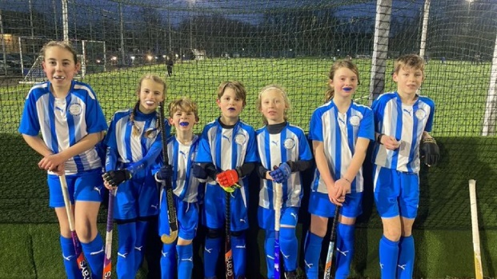
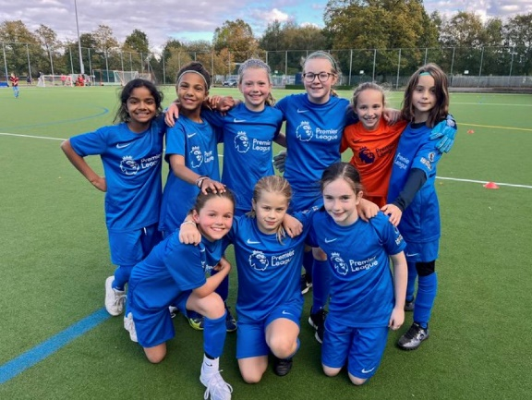
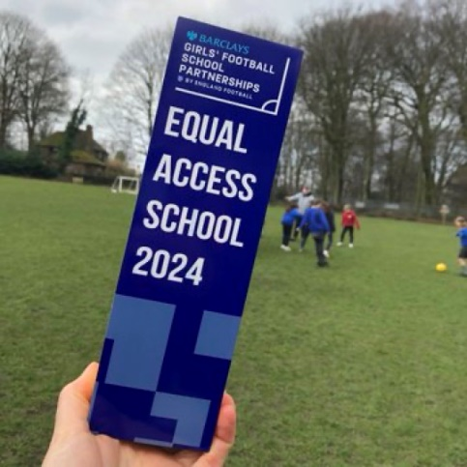
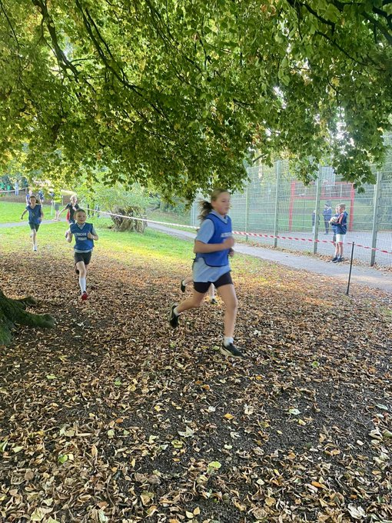
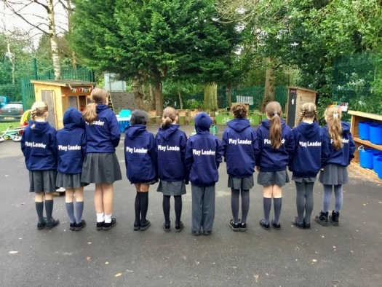
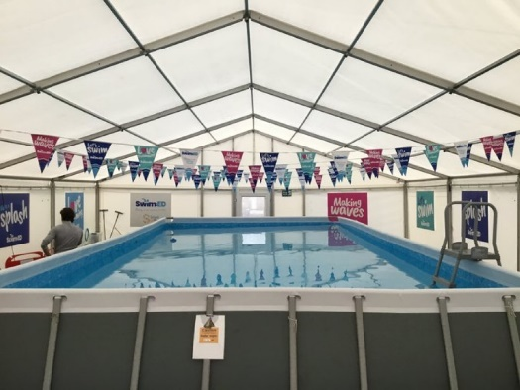
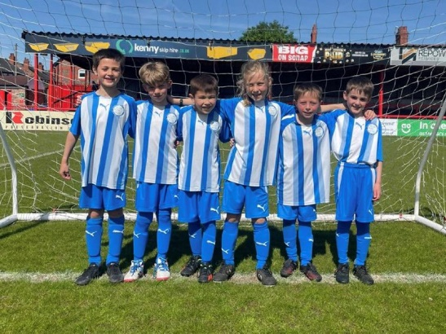
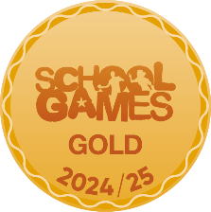
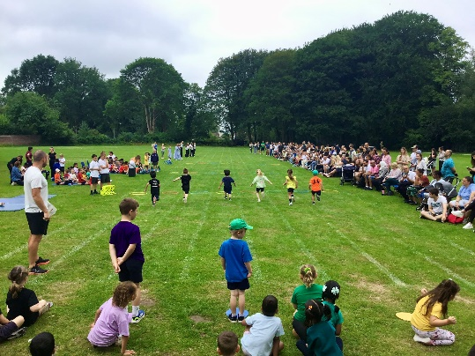
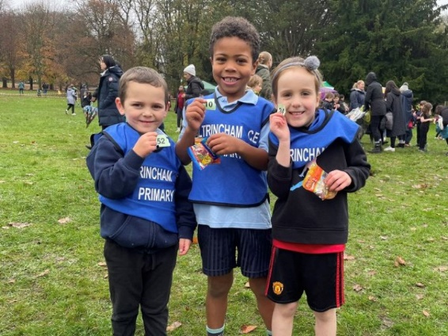
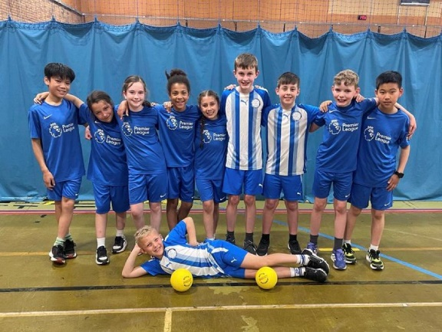


ACE PE and Sport
Action Plan and Report 2024/25

PE and Sport Premium allocated for 2023/24 (£16,000 + £10 per pupil) | £18,010
Total spend 2023/24 | £18,053
Funding 2024/25
Key priorities and Planning 2024/25

Action – what are you planning to do? | Who does this action impact? | Key indicator to meet | Impacts and how sustainability will be achieved? | Cost linked to the action
Continue with one day a week Altrincham FC and two days a week Sam  Continue to update and receive regular CPD on the PE Passport app  Specialist coaches and class teachers to team teach, leading to class teachers delivering some lessons with coach as support.  ALL coaches/teachers to follow PE passport planning and assessment | Teaching staff  Coaches  Pupils  PE Lead | Key Indicator 1 - Increased confidence, knowledge, and skills of all staff in teaching PE and sport | Staff feel more confident to in their ability to deliver high quality PE lessons  All coaches using PE Passport effectively | £11,145 - specialist coaches  £500 - PE Passport App
Continuation of extensive programme of extracurricular sports.  Audit and replenish equipment and storage | Teaching staff  Coaches  Pupils  PE Lead | Key Indicator 2 -The engagement of all pupils in regular physical activity | More pupils meeting their daily physical activity goal  New equipment ordered and being used | £3,498 – new equipment and resources
Renewal of Trafford SSP membership –Tier 1  Update PE and Sports displays around school  1) Photos of a range of PE lessons + PE vocab  2) School Sports photos and reports  3) General info - PE kit photos, timetables, Sports Leaders, rules and reminders | PE Lead  Pupils | Key Indicator 3 – The profile of PE and Sport is raised across the school as a tool for whole school improvement | PE promoted across school as a valuable subject. PE is a prominent and respected part of the school culture. | £2,840 - TSSP Subscription
Continue to explore new sports and activities e.g. martial arts, boxing, street dance etc.  Book one off events – inspirational visitors, trips to professional sports events etc. | Local sports clubs  PE Lead  Pupils | Key Indicator 4 - Broader experience of a range of sports and activities offered to all pupils | Pupils have the opportunity to explore different activities and develop a well-rounded understanding and enjoyment of PE | £1,000 - One off events
Continue to participate in a wide range of local and borough-wide competitions to enable ALL children to have an opportunity to compete and represent Team ACE.  Fun festivals / B+C Team tournaments etc  Host netball match for local schools  Set up a system for borrowing and return of Sports Kits | TSSP  PE Lead  Coaches  Teaching staff  Pupils | Key Indicator 5 - Increased participation in competitive sport | Inclusive and supportive environment created, offering a variety of activities that cater to different interests and abilities | £4,000 - transport and supply cover costs

Key achievements 2024/25

Activity/Action | Impact | Next Steps for 2025/26
- School Games Mark – Gold (4th year running)  - Reduced specialist coaches from 3 to 2 (saving £5,700 a year)  - Successful Swim:Ed programme delivered for Y4+5 (Pop up pool for 5 weeks on playground)  - Participation in 27 interschool tournaments including football, hockey, rugby, swimming, cross country, netball, dodgeball and multi-sports  - Y5/6 B and C Team boys’ football tournament  - International Women’s Day Girls’ football tournament  - Y6 OAA residential trip - Min y Don Adventure Centre  - Regular twitter / Instagram / Facebook updates  - PE Lead attended the termly TSSP Subject Leader meetings  - Broad and balanced curriculum with specialist coaches teaching all classes  - Continued effective use and development of the PE Passport app  - Team of Y5 Play Leaders set up and trained  - New XC bibs purchased  - Participated in Altrincham District Athletics Club Primary Schools Cross Country, in John Leigh Park  - Participation in KS2 Athletics tournament (50 children)  - Wide range of extracurricular clubs for N-Y6 including dodgeball, netball, football, cricket, rugby, athletics, multisports, hockey, tennis and dance  - Free access to extracurricular clubs for Pupil Premium children  - Two successful Sports Days, well attended by parents  - Weekly celebration of KS2 sporting achievements in Friday assembly  - Playtime equipment and storage purchased  - ‘ACE ways to be Active’ display, showcasing ways pupils (and staff!) are active outside school | Pupils have benefitted from a broad, balanced and engaging PE curriculum, experiencing a wide range of activities and developing their physical literacy.  Teachers have increased confidence in their teaching abilities, leading to more effective instruction and higher levels of pupil engagement.  We have created a positive and inclusive environment where pupils feel motivated to participate and excel. | Purchase new netball kits  Purchase waterproof suits for EYFS for OAA and Forest School  Intra-sport tournaments  Organise more one-off sports events and inspirational visitors  Introduce a new sport - Kin Ball (purchase resources)  Renew playground markings (EYFS, KS1 and KS2)  Staff v children matches!

Swimming Data – Current Year 6 cohort
Meeting National Curriculum requirements for swimming and water safety.

Question | Stats: | Further context relative to local challenges
What percentage of your current Year 6 cohort can swim competently, confidently and proficiently over a distance of at least 25 metres? | 81 | Our local Swimming pool has been closed for refurbishment for two and a half years
What percentage of your current Year 6 cohort can use a range of strokes effectively [for example, front crawl, backstroke, and breaststroke]? | 72
What percentage of your current Year 6 cohort are able to perform safe self-rescue in different water-based situations? | 80
If your schools swimming data is below national expectation, you can choose to use the Primary PE and sport premium to provide additional top-up sessions for those pupils that did not meet National Curriculum requirements after the completion of core lessons. Have you done this? | No
Have you provided CPD to improve the knowledge and confidence of staff to be able to teach swimming and water safety? | No

Signed off by:

Head Teacher:
Subject Leader or the individual responsible for the Primary PE and sport premium: | S Hornby – PE and Sport Lead
Date: | June 2025

