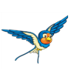
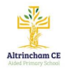
Swallows Class Newsletter
Summer Term 2026
Dear parents and carers,
Welcome back, I hope you had a fun and exciting Easter break. We are on the final term with lots of exciting things planned.
A few reminders:
Children should wear PE kits for their PE lessons on Tuesday and Thursday for this term.
Homework:
Maths homework is now all online. If you require a login reminder for
TT Rock Stars or MyMaths please just let me know. Maths homework will be set every Tuesday.
English - Reading is recommended every day for at least ten minutes. It is expected that children will keep a record of what they have read and bring these into school regularly. Children will have the opportunity to change their books throughout the week as necessary. Handwriting practice will be set each Monday. It is important children practice their handwriting and begin to join as this aids their creative writing enabling them to write at pace.
Dates for the diary: Author Presentation Thursday 30th April
Half Term Break – 25th May – 5th June
School Class photos - Tuesday 16th June
KS2 Sports Day – Tuesday 7th July –parents welcome to attend.
Singing Festival Thursday 9th July – parents welcome to attend.
School finishes for summer break – Wednesday 22nd July 2pm
Details of our exciting curriculum for this half-term can be found below.
Any queries you can always catch me at morning drop off, afternoon pick-up or leave a message with the office team and I will get back to you as soon as possible.

Best wishes,

Miss Stevens
English  The Pathway to Write key texts for this term are ‘Journey’ by Aaron Becker and ‘Zeraffa Giraffa’ by Diane Hoffmeyer. The children will be working towards achieving the key Year 3 English writing objectives such as: using inverted commas, use adverbs and adverbial phrases to indicate time, use expanded noun phrases to describe and use different present and past tenses. Book Club will use a varied of text extracts which form the new reading spine. The class novels for the term are ‘White Fox’ by Jackie Morris and ‘The Lion , the witch and the wardrobe’ by CS Lewis. |  | Maths  Learning challenges from White Rose take in the final unit on fractions. We will then look at shape, space and measure by looking at time, money and shape. Our final unit for the year will be statistics. Please do log in and complete the MyMaths homework as this consolidates units completed in class.  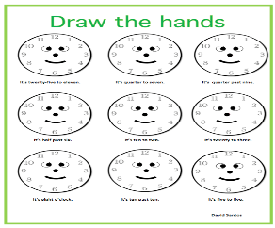
Science  The science units for this term include looking at plants, forces including magnets.  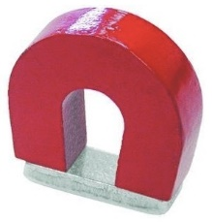 | History  The children will continue to research and explore different eras in history. This term they will be learning about the Roman Empire.  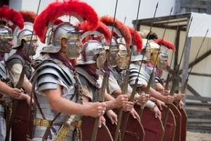 |  | P.E.  The children will revert to PE sessions on a Tuesday afternoon and Thursday morning. They will be doing athletics and tennis.  
R.E.  The children will continue with the Questful RE scheme and will explore the units on ‘Rules for Living’ and Christian Art.  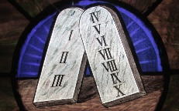 | PSHE  The children will continue exploring the Jigsaw scheme and the units on Relationships and Changing Me – this includes sex education.   |  | Music  Music follows the Charanga scheme and we will be Baroque music.  
French  Following the Primary Languages Network scheme the children will be learning the French vocabulary for fruit and vegetables as well as being able to say where we live.  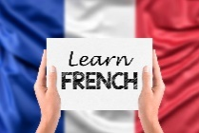 | Geography  The children will be learning about international trade.   |  | Art and DT  The children will be looking at featured artist Kandinsky in abstract art. In Dt they will be looking at paper circuits.  

