
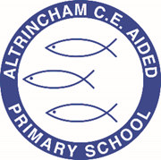
Year 1 Woodpeckers Class

@acewoodpeckers

@@
‘


Curriculum Newsletter
Summer 1 - 2026

Dear parents and carers,

I am so excited to be back in school and have a fun and educational last term in year 1. Summer 1 has arrived and the weather is looking up. We have so much exciting learning to finish until the end of the year.

Details of our irresistible curriculum for this half-term can be found below. Remember you can follow our instagram feed and see what we are doing!

A few reminders:
*Children are to wear PE kits on a Tuesday and Wednesday (for COAL). Please remove any jewellery or provide tape to cover earrings, and long hair to be tied back.
*School is a nut free school, this includes no nuts in lunch boxes (no hazelnut spreads) and sweets/chocolates brought in to share for birthdays.
*The school day is 8.50am to 3.20pm. The gates are locked at 9am and any late comers will need to report to reception. If any children have not been collected by 3.30pm they will be taken to the Arc after school club and charges may apply.

Any queries you can always catch me at morning drop off, afternoon pick up and via seesaw.

Best wishes,

Miss Manock

English  The English Framework at ACE includes a daily session of Book Club. The children are grouped according to the phonics phase they are working in. Within these Book Club session there are phonics activities and guided reading activities. In addition to Book Club there will also be English lessons. These will include grammar and spellings bursts and activities around a key text. Y1 Key Text ‘Toys in Space’ by Mini Grey.  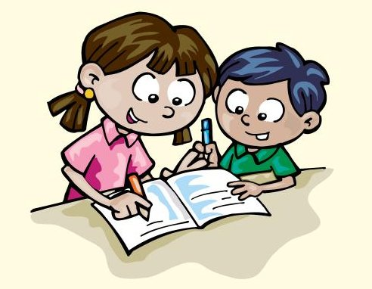 |  | Maths  We follow the White Rose Maths Scheme. Year 1 will be starting to learn about measurement (length, height, mass, volume) before moving onto multiplication and division.  
Religious Education  School has moved to a new scheme for RE, Questful RE. Year 1 will be reading stories taken from the Old Testament and talking about how these stories teach us to be respectful and kind people.   | Science  We follow the White Rose Education Scheme. Year 1 will be revisiting the plants topic, looking at its features and comparing different plants that we find in the wild/at home or school.  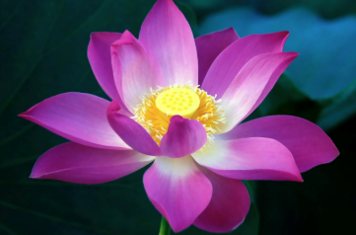 |  | Computing  We will be following the Teach Computing Scheme. Our topic this half term is creating media, - digital writing.  
Geography  In Geography this half term we will be looking at the different seasons and weather than comes with this. We will then look at the different types of extreme weathers we can have all around the world.   | COAL  Creative, outdoor and adventurous learning. These sessions will be on a Wednesday afternoon and include ICT and sports.  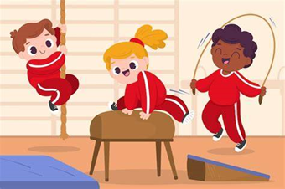 |  | PE  We follow a scheme called ‘PE Passport’ The units for Y1 include athletics and fundamental movement skills.  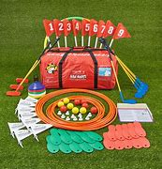
PSHE  We follow the Jigsaw scheme for PSHE. The theme for this half term is relationships. This includes relationships with family, friends and ourselves.  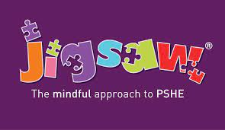 | Worship  Every week your child will be participating in whole school, Key Stage and class worships.  

