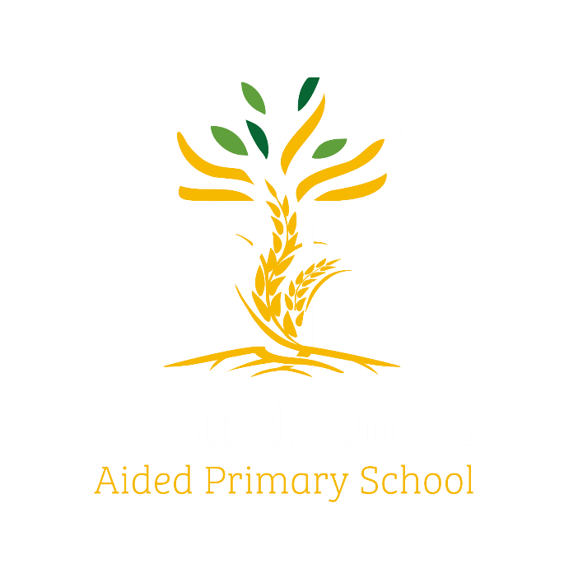
Year 6 Eagles

Curriculum Newsletter: Summer 2026

Dear Parents and Carers,

I am sure we all have mixed feelings about the coming term as I am sure the pupils do too: some will be counting down the days until they start secondary school whilst others will be savouring each day of their final term in primary school. Whatever your child is feeling, we will be there to support them through their transition from year 6 to year 7. We have an action-packed term ahead of us with lots of valuable learning ahead.
Details of our curriculum for this half-term can be found below.
Remember you can follow our school Instagram feed and see what we are doing!

History  “Golden Years of Baghdad” is our next intriguing topic title. We will be learning about the Islamic Empire from the 8th Century, including the importance of the “Silk Road” and the wider historical context.  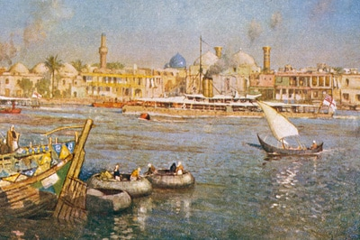 |  | English  Key Text: Manfish  by Jennifer Berne  This is a beautiful book, which combines superb artwork with poetic language to relate the inspiring life story of world-renowned oceanographer, Jaques Cousteau.  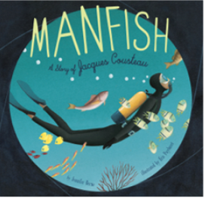  Children will explore multi-media texts to support research and develop the children’s understanding of different forms of biographical writing. |  | Maths  We wiil complete the White Rose learning for Year 6, focusing geometry, algera and ration and plenty of revision of computation and the number system.  
Geography  We’re going on a South American Road Trip! As we learn about the countries on this fascinating continent, we’ll look at modern life in different localities, exploring physical and human geographical features.  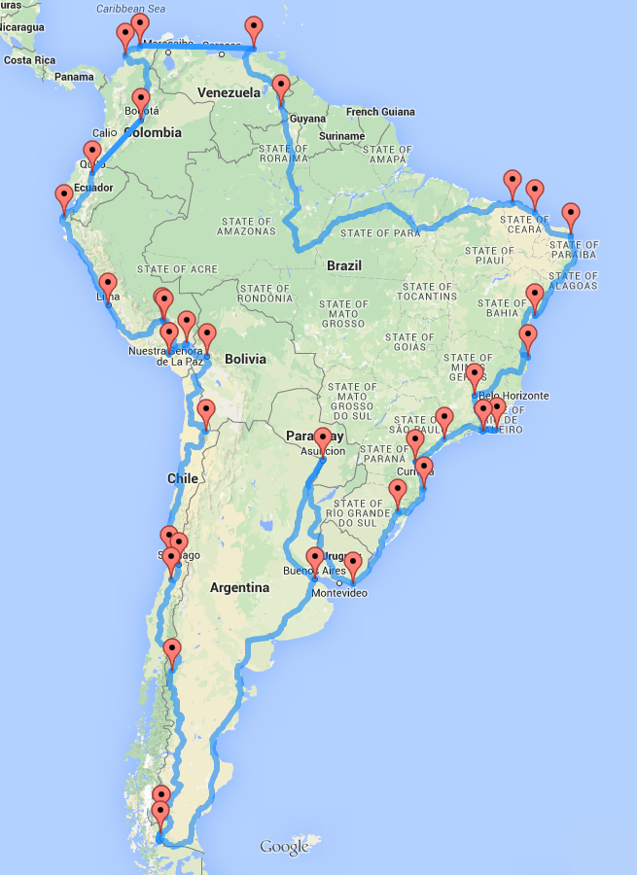 |  | Religious Education  The children are invited to grapple with another huge question this term: What is the nature and character of God? This is centred on Bible passages and ideas about the Holy Trinity and also explores different faiths and worldviews.  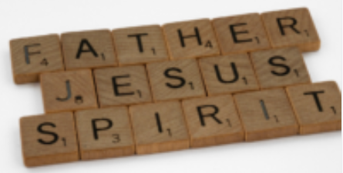 |  | Physical Education  PE lessons will take place on Mondays and Fridays. This term we are working to improve our skills in athletics and badminton.  
Computing  We. | Music  Our Charanga music lessons are based on another YuStudio project; this one is called “Dragon Beats” and explores a broader range of orchestral instrumentation.  We look forward to showcasing our musical performance skills in our end of year production – details to follow. |  | Science  Are humans more similar to other animals than we think? We will explore variation, adaptation and evolution. Later in the term, we will find out about natural history as we study fossils.  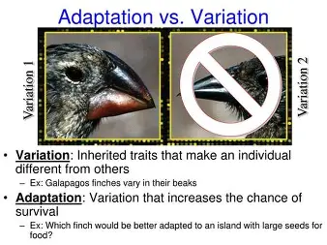
French  Our first theme this term is “Café Culture”. As well as learning some food and drink vocabulary and consolidating simple sentence grammar, children will learn about modern French culture. The second topic is, appropriately as Year 6 reach a milestone, “Celebration”.   |  | PSHE  The two puzzles for us to study this term are “Relationships” and “Changing Me”.   |  | COAL  On Thursday afternoons our curriculum is fuelled by computing, outdoor and adventurous learning. This term Eagles Class will take part in forest school lessons.  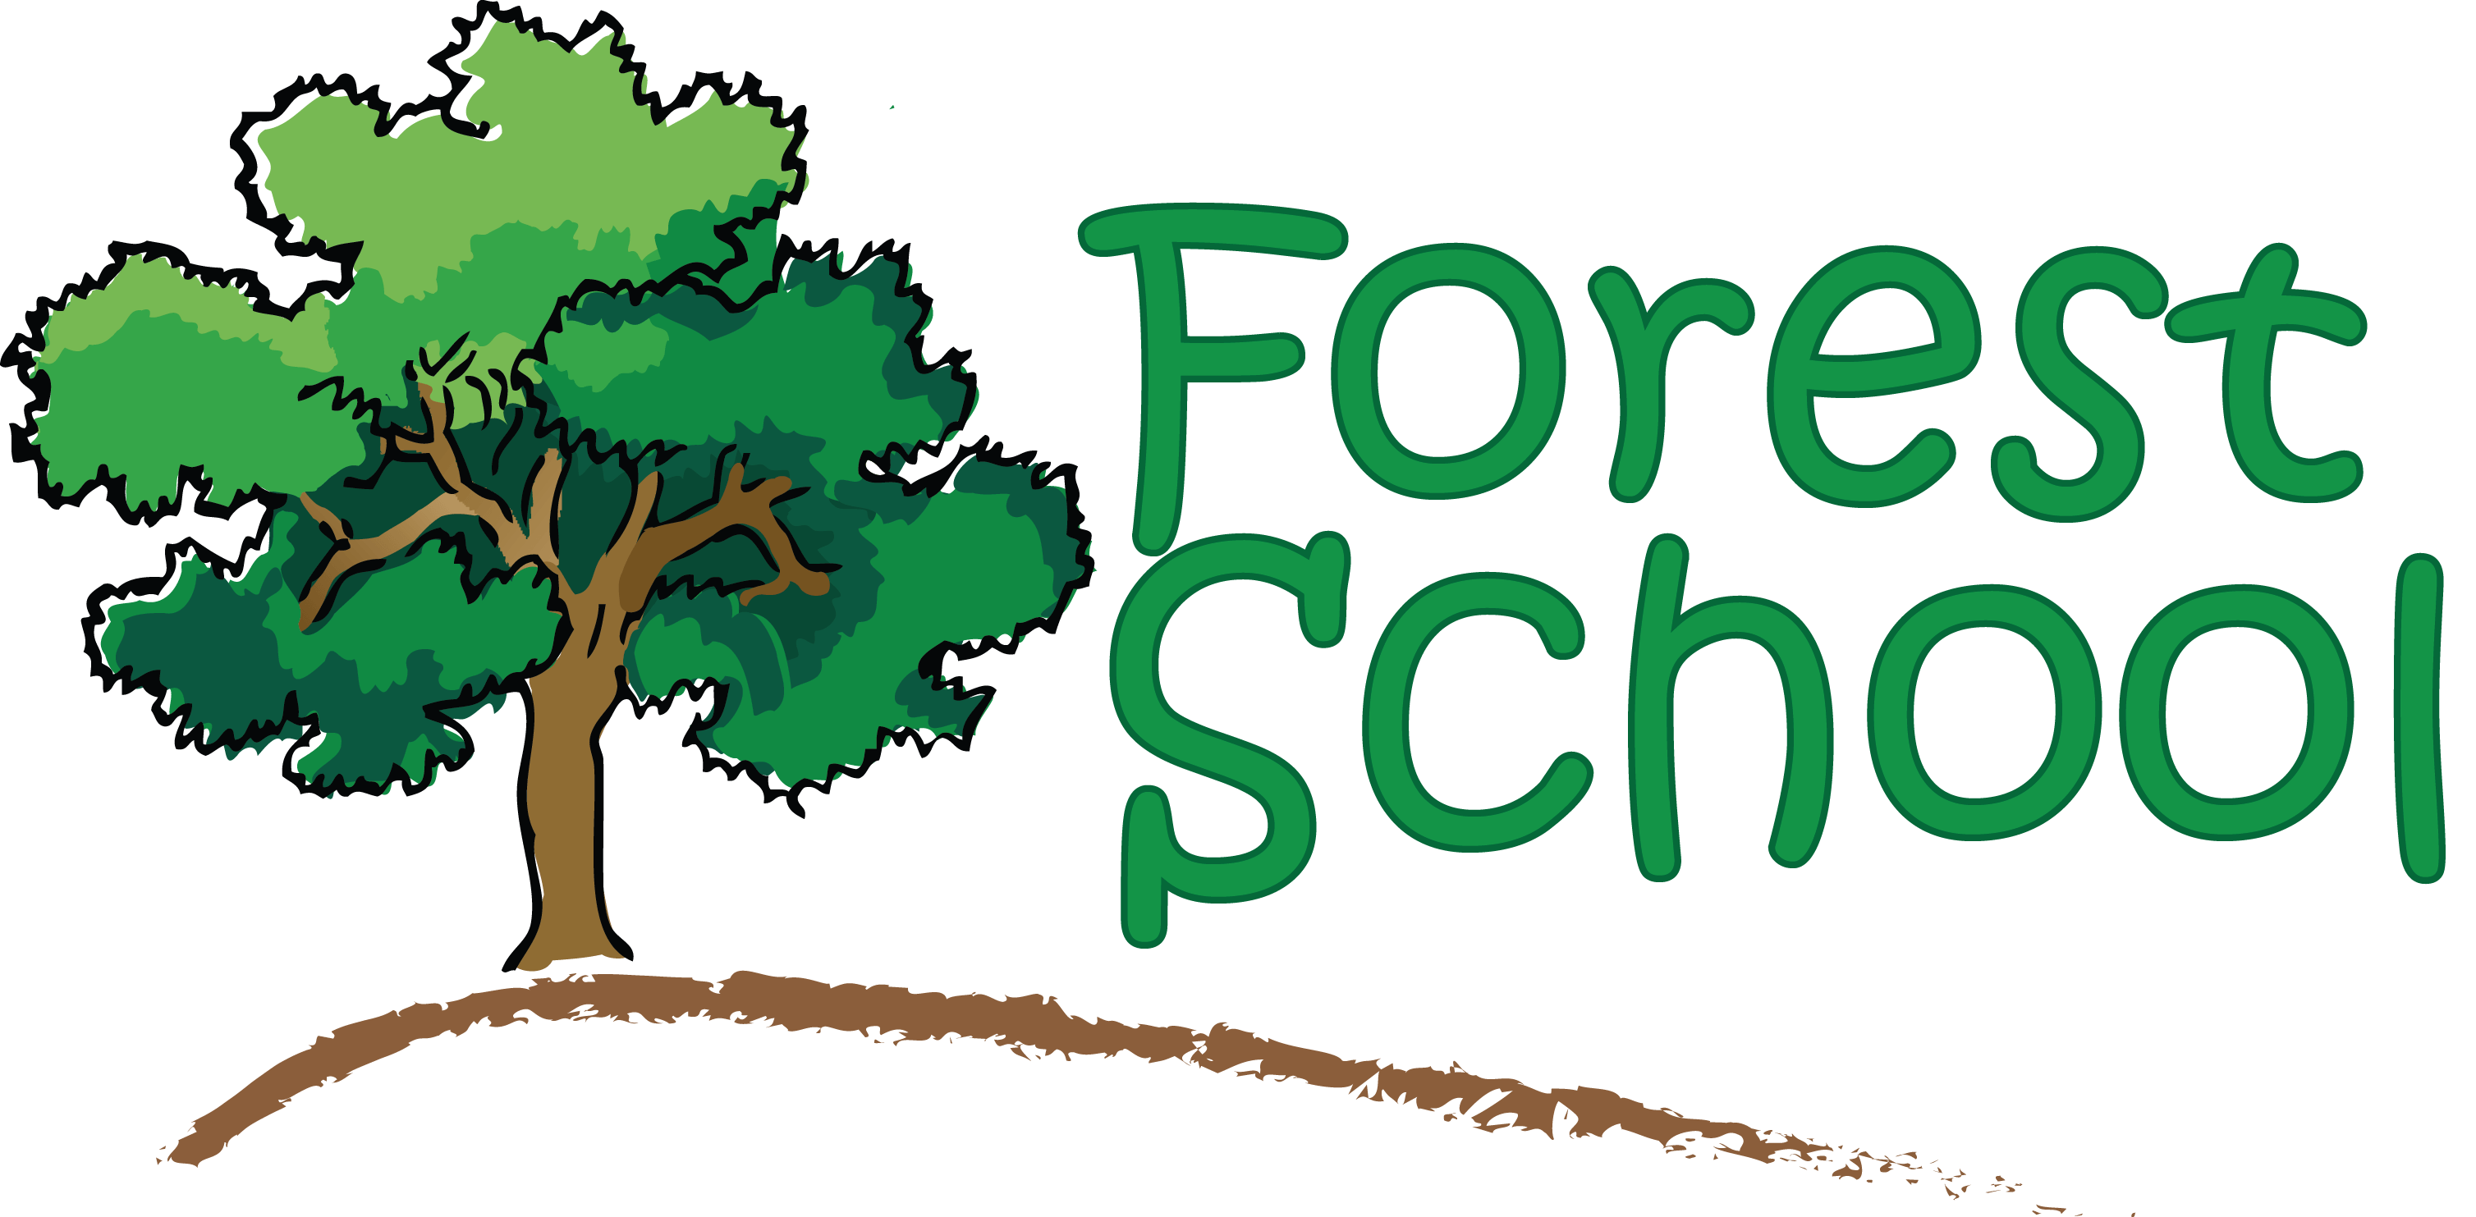

Reminders

PE will be on Mondays and Fridays. Please make sure children wear appropriate footwear for PE and come to school dressed in their PE kits.
Homework for maths will be set on Thursdays using our new My Maths platform, to be completed by the following Thursday, when it will be reviewed in class. English homework will be set each Monday, focusing a mixture of Book Club reading tasks and grammar revision from Spag.com. Reading books and filled water bottles should be brought to school every day please. Thank you.

