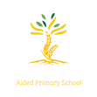
Year 5 Nightingales

Curriculum Newsletter: Summer i 2026

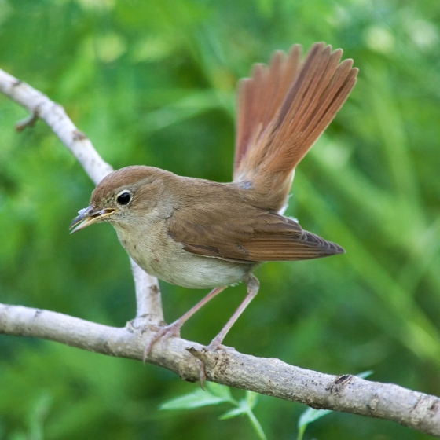
Dear Parents and Carers,

I hope you have all enjoyed a relaxing and enjoyable Easter break. We look forward to a new term of learning. Details of our irresistible curriculum for this term can be found below. Remember you can follow our Instagram feed and see what we are doing!

English  Key Text:  The Paperbag Prince by Colin Thompson  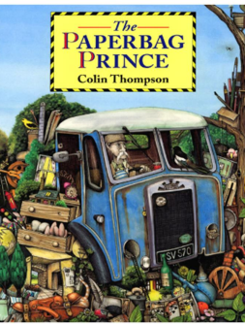  Using this text as inspiration, pupils will write a persuasive text about waste management. They will use our ACE Writer’s toolkit, and use techniques such as building cohesion within paragraphs and apt vocabulary choices, to achieve their purpose and address a desired audience. | Geography  We will be looking at South America. Pupils will look at the continent’s diverse environmental regions, physical landmarks and human characteristics.  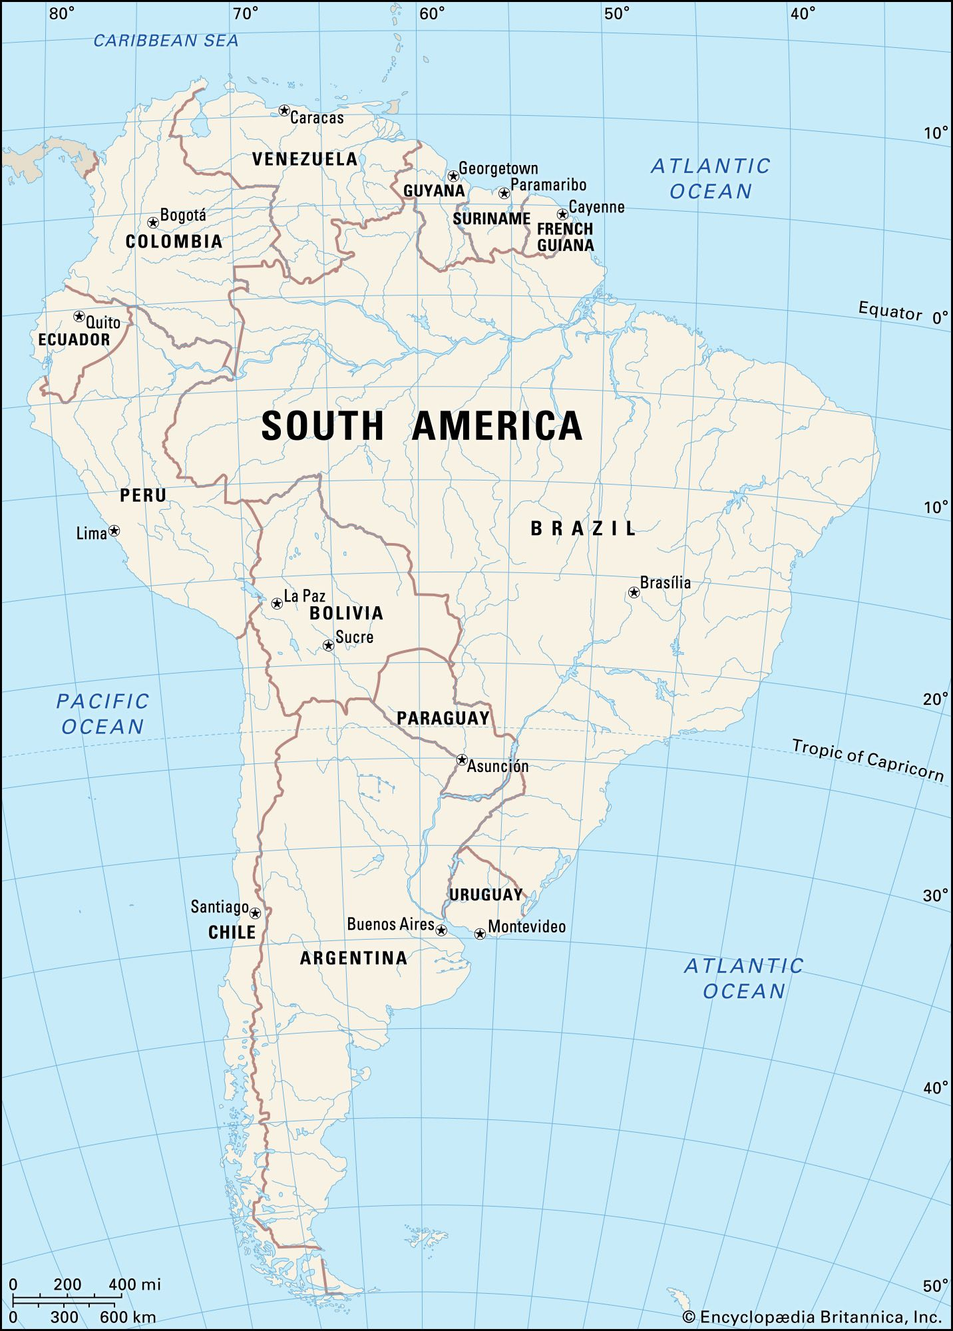 |  | Maths  This term, White Rose Maths focuses on shape, position and direction, decimals, converting units, and volume.  We will also be continuing to work on our arithmetic skills.  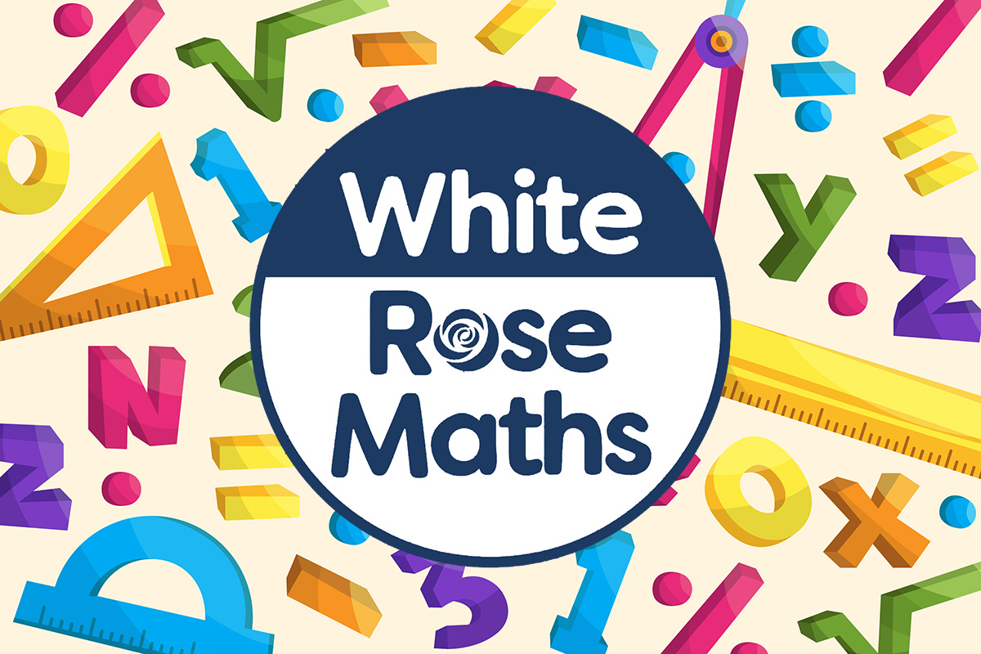
 | Religious Education  The RE topic that we will be looking at is called ‘Did she make the right choice?’. The aim of the unit is to look at the role and significance of women in the Bible and God’s big story.   |  | Physical Education  PE lessons will take place every Monday morning. The children will be taught how to play badminton. Additionally, children will develop a range of team sport skills.  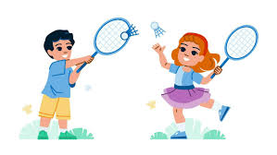
Computing  Pupils will develop their knowledge and understanding of programming, specifically looking at selection in quizzes. In this unit, pupils develop their knowledge of selection by revisiting how conditions can be used in programs and then learning how the If… Then… Else structure can be used to select different outcomes depending on whether a condition is true or false.  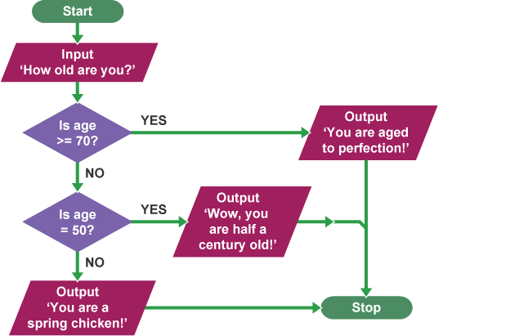 |  | Science  Pupils will look at reversible and irreversible changes. They will begin this topic by looking at what dissolving, filtering and sieving are. They will then look at solutions, evaporation and discussed which changes can be reversed and which cannot.  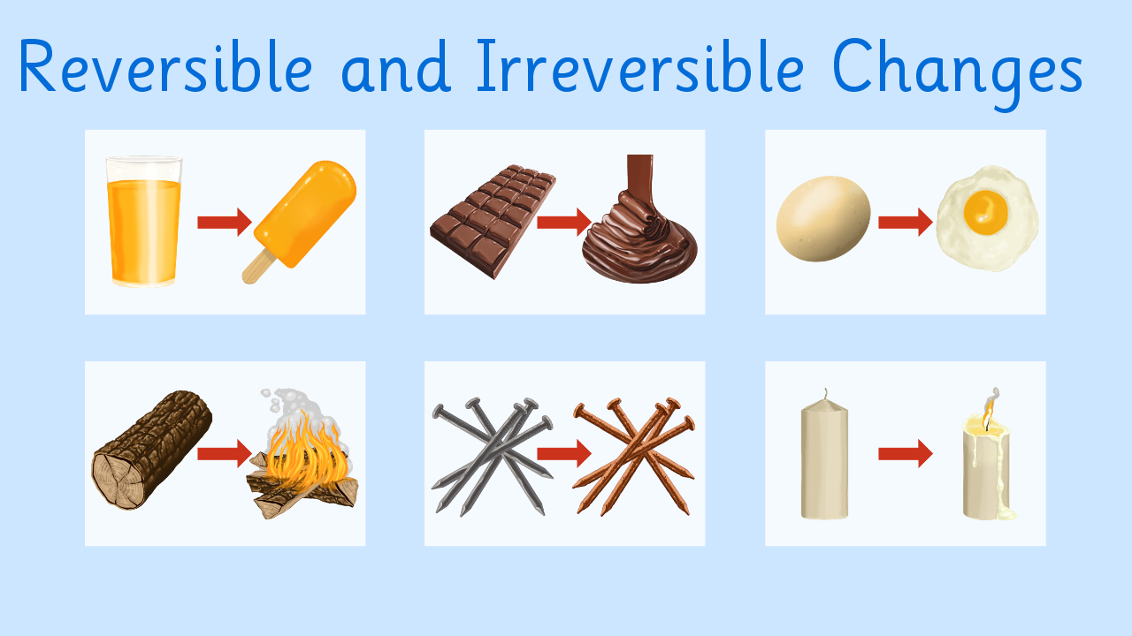
French  We will practise conversational phrases to allow us to engage in short dialogue with each other. We will respond to instructions given in French as well as using masculine and feminine nouns.   | PSHE  “Relationships” puzzle from our Jigsaw programme. This focuses on the ways in which we look at ourselves, joining and staying safe in an online community, online gaming and our relationships with technology.   |  | COAL  On Thursday afternoons our curriculum is fuelled by creative, outdoor and adventurous learning. This term Nightingales will have music lessons and will be participating in various athletics-based activities.  

Reminders

On PE days please send your children in their PE kits, which they will stay in for the entire day on Mondays and Thursdays. Please be mindful that the children will need to wear tracksuit bottoms, or shorts, and tops or t-shirts; these need to be blue.
Homework for maths and English will be set on Fridays, to be completed by the following Friday. Reading books should be in school every day please. I am looking forward to another fantastic term and thank you in advance for all your support in these matters.

Mr. Aljilani 😊

