
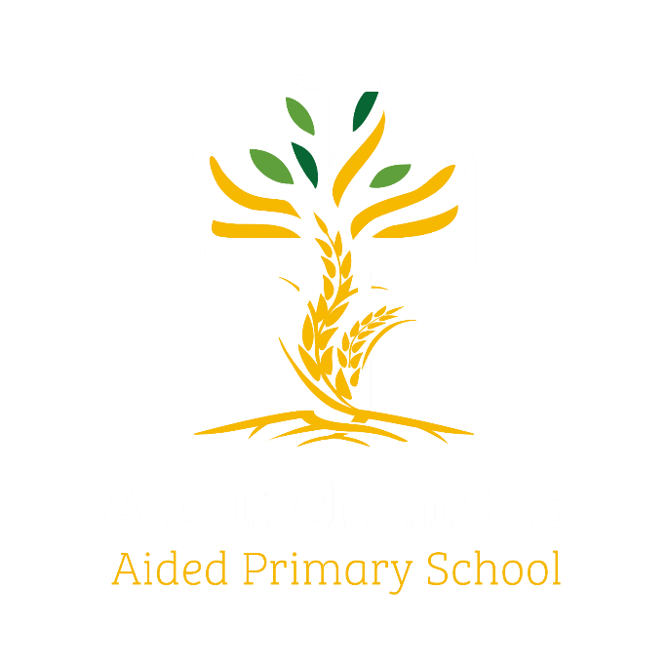

Year 1 Woodpeckers
@altrincham.ce

Curriculum Newsletter: Autumn 2025

Dear Parents and Carers,

I am delighted to welcome all the children into Woodpeckers Class for the new school year. After a long, hot summer, we’re refreshed and ready to dive into our exciting new units of learning. I’m looking forward to meeting you in person at our “Meet the Teacher” evening on Monday 15th September. This will be a great opportunity to share our vision and key objectives for the year ahead. Details of our irresistible curriculum for this half term can be found below.

Don’t forget to follow our whole school Instagram to see what we’ve been up to!

History  ‘The Great Fire of London’.  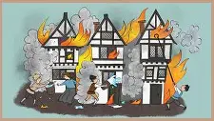  We will be talking about events beyond living memory that are significant nationally or globally. | English  Key Texts:  Lost and Found  by Oliver Jefferies  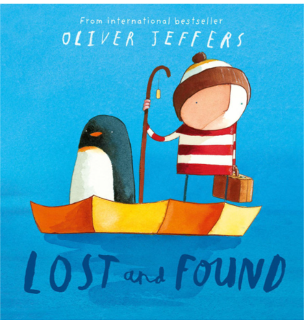  Nibbles the Book Monster  by Emma Yarlett  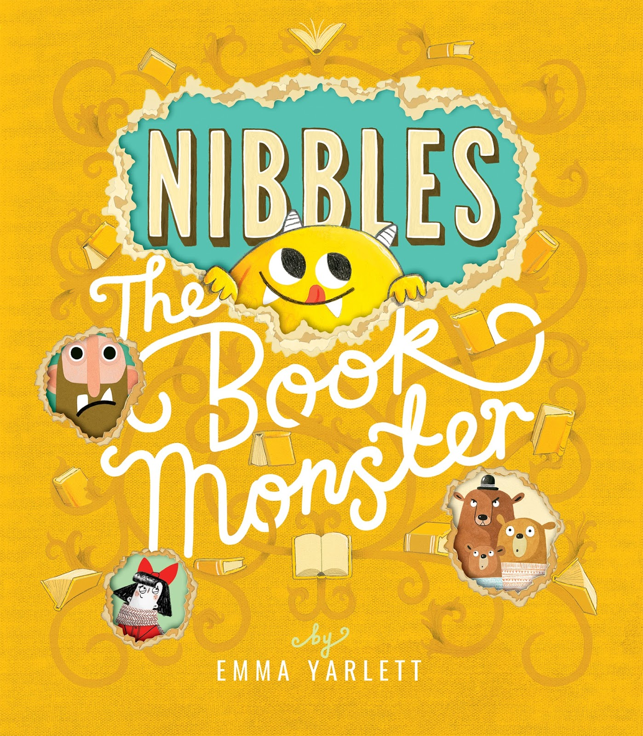 | Maths    Learning challenges from White Rose include Place Value, Addition and Subtraction and Geometry (shapes).
Geography  We will be learning all about the seven continents and    five oceans. | Religious Education  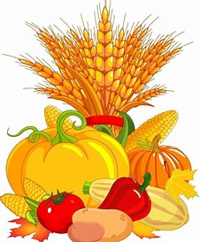  We will explore Christian beliefs about baptism and look at the celebration of Harvest. | Physical Education  PE lessons will take place on a Tuesday with a specialist teacher and a Thursday with the class teacher. This half term we will be learning about invasion games.  
Computing  This term we will become more familiar with the different components of a computer by developing their keyboard and mouse skills, and also start to consider how to use technology responsibly.   | Science  This term we explore the human body, seasonal changes and look at different types of materials.  
Languages  We will learn a variety of languages, build vocabulary, and explore the patterns and sounds of language through  songs and rhymes.   | PSHE  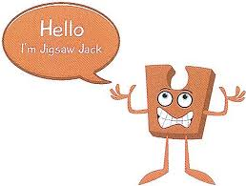  “Being Me in My World” puzzle from our Jigsaw programme. | COAL  On Wednesday afternoons our curriculum is fuelled by creative, outdoor and adventurous learning.    This half term Woodpeckers will do forest school until October.

Reminders
On PE days, please ensure that children wear appropriate footwear and come to school dressed in their PE kits. PE will take place on Tuesdays and Thursdays.
Reading books are sent home every Tuesday. Please read with your child, fill in their reading record, and return both the book and record to school, ready to be changed the following week.
Next week, we will provide login details for Phonics Bug Club and TT Rockstars/Numbots to help consolidate learning outside of school.
Please ensure that book bags and water bottles are brought to school every day. Thank you for your continued support.
Kind regards,
Miss Ruane

