
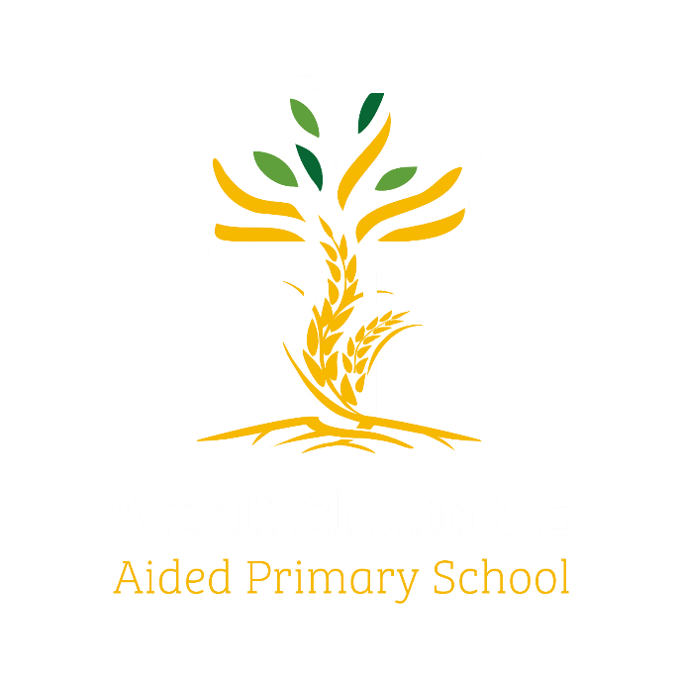

Year 1 Woodpeckers
@altrincham.ce

Curriculum Newsletter: Spring 2026

Dear Parents and Carers,
It’s hard to believe we are already well into the Spring term. I hope you all had a relaxing break and were able to spend plenty of time with friends and family.
Details of our exciting and irresistible curriculum for this term can be found below.
Don’t forget to follow our whole-school Instagram to see what we’ve been up to!
History  ‘The Great Fire of London’.  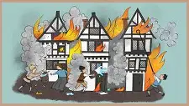  We will be talking about events beyond living memory that are significant nationally or globally. | English  Key Texts:  The Lion Inside  By Rachel Bright and Jim Field    The Curious Case of the Missing Mammoth  By Ellie Hattie &  Karl James Mountford  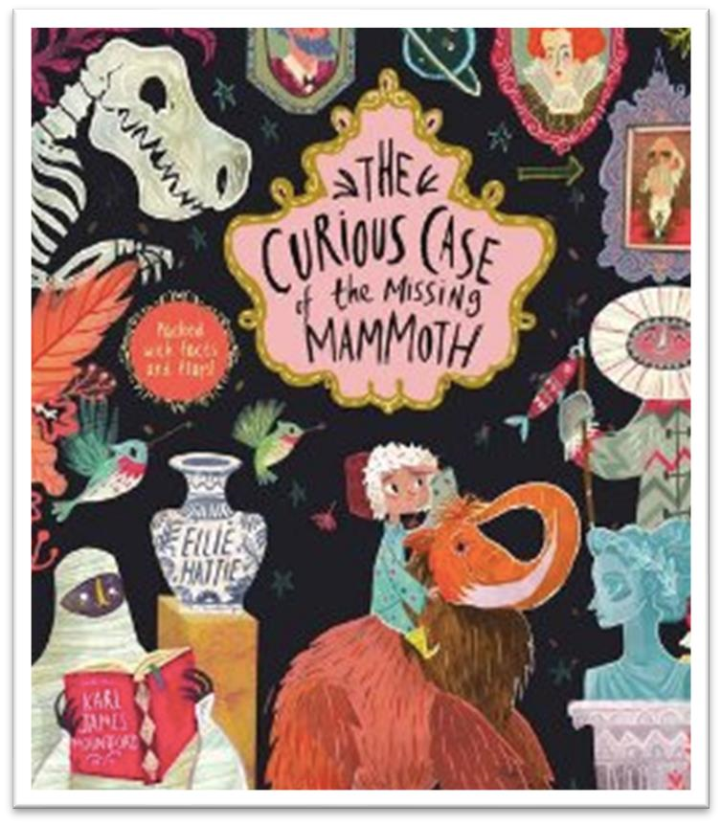 | Maths    Learning challenges from White Rose include place value (within 20 and 50), addition and subtraction (within 20), length and height, and mass and volume.
Geography  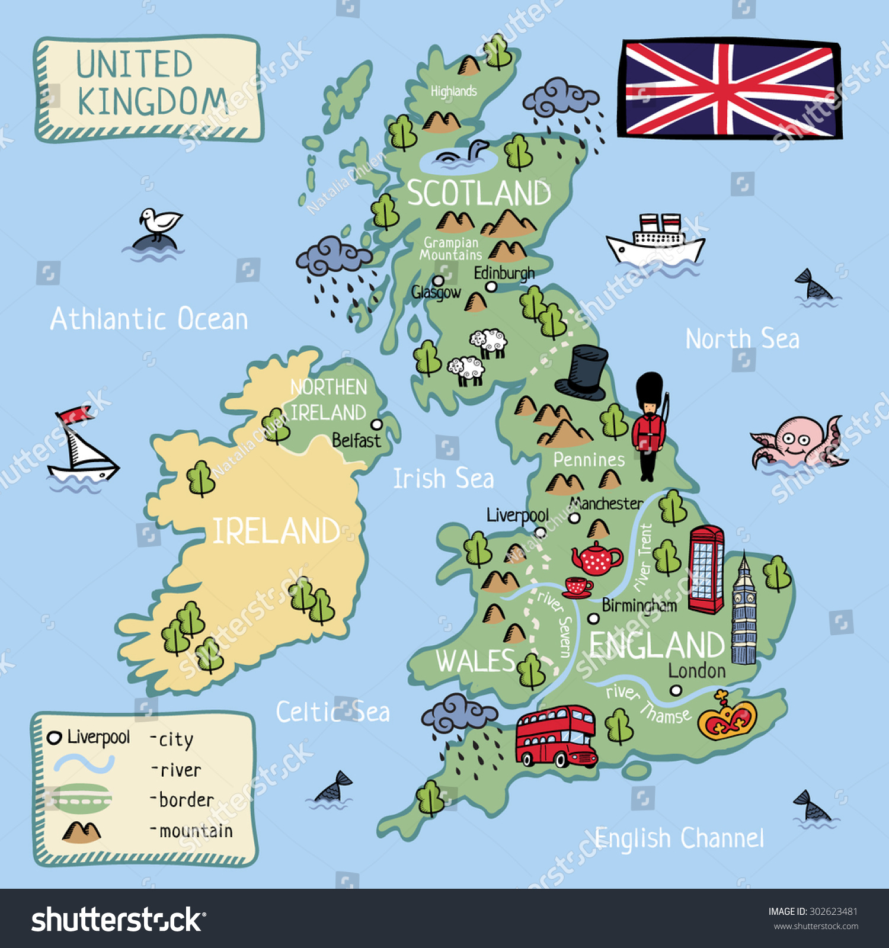  This term in Geography, pupils will learn about the United Kingdom and London. They will use simple geographical vocabulary and observation skills to understand where places are and what they are like. | Religious Education  We will explore the significance of Jesus and look at the celebration of Easter.   | Physical Education    PE lessons will take place on Tuesdays with a specialist teacher and on Thursdays with the class teacher. This term, we will be focusing on fundamental movement skills and striking and fielding games.
Computing  After the February half term, the children will have computing lessons on Wednesday afternoons during COAL. This term, they will be creating media and exploring digital painting using a range of creative tools.   | Science  This term we will be looking at planting seeds and explore the different parts of a plant before moving onto different groups of animals and their qualities.  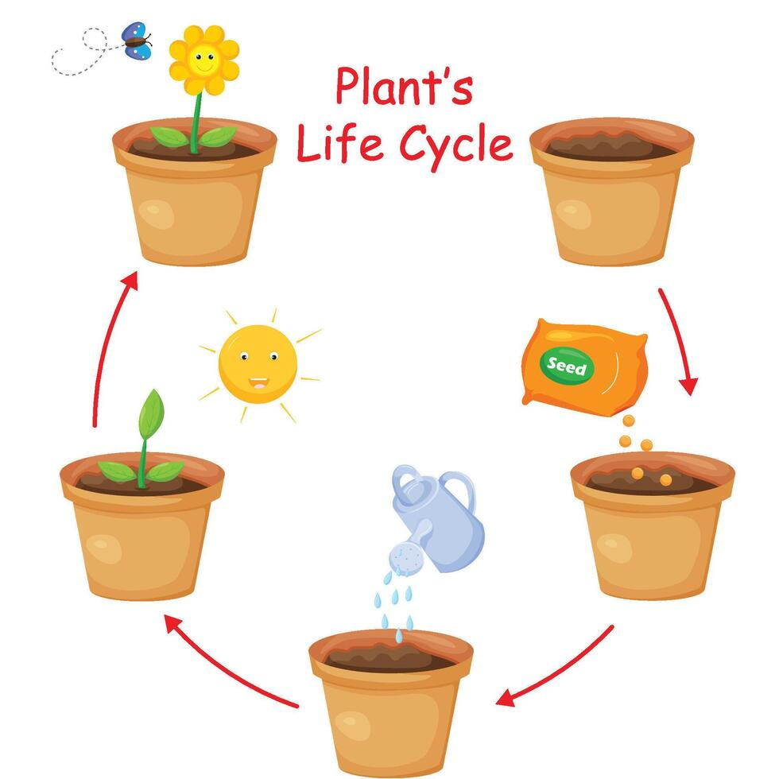
Languages  We will learn a variety of languages, build vocabulary, and explore the patterns and sounds of language through  songs and rhymes.   | PSHE    “Dreams and Goals”  puzzle from our Jigsaw programme. | COAL  On Wednesday afternoons our curriculum is fuelled by creative, outdoor and adventurous learning.    This half term Woodpeckers will do forest school until February.

Reminders
On PE days, please ensure that children wear appropriate footwear and come to school dressed in their PE kits. PE lessons will take place on Tuesdays and Thursdays. In addition, until the February half-term, children will also need their PE kits on Wednesdays for Forest School, alongside their Forest School kit.
Reading books are sent home every Tuesday. Please read with your child, complete their reading record, and return both the book and record to school ready to be changed the following week. Please ensure that your child’s yellow reading record is always kept in their book bag. This allows me, or another adult, to leave comments whenever we read with them in school.
Homework is optional; however, I strongly encourage children to complete the MyMaths task set each Monday, log in to Numbots regularly to practise their number skills, and read the allocated books on Phonics Bug. Reading is extremely important, so please try to read with your child every day where possible. From this week, I will also be sending home the ‘sounds of the week’ that we have learned in phonics. Practising these at home will greatly support your child and help prepare them for the upcoming phonics screening.
Finally, please ensure that book bags and water bottles are brought into school every day.
Thank you for your continued support.
Kind regards,
Miss Ruane

