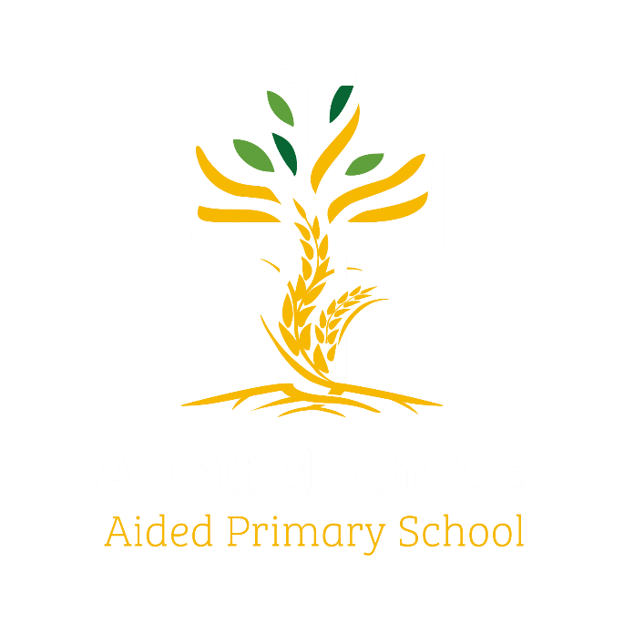
Year 6 Eagles

Curriculum Newsletter: Spring 2026

Dear Parents and Carers,

Happy New Year everyone! We are looking forward to lots of exciting learning opportunities throughout the spring term.
Details of our curriculum for this half-term can be found below.
Remember you can follow our school Instagram feed and see what we are doing!

History  How did the events and conclusion of World War 1 contribute to the outbreak of war in 1939? We will study life in Britain during World War II and, in particular, its impact on our local area.  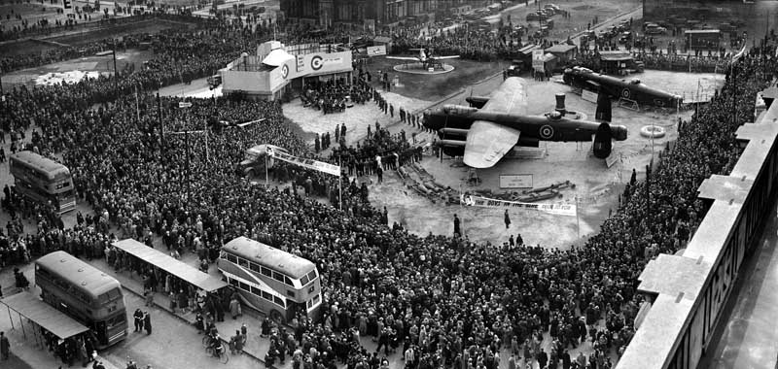 |  | English  Key Texts:  Goodnight, Mr Tom by Michelle Magoriam; Carrie’s War by Nina Bawden; Rose Blanche by Roberto Innocenti; poetry  written in response conflict.  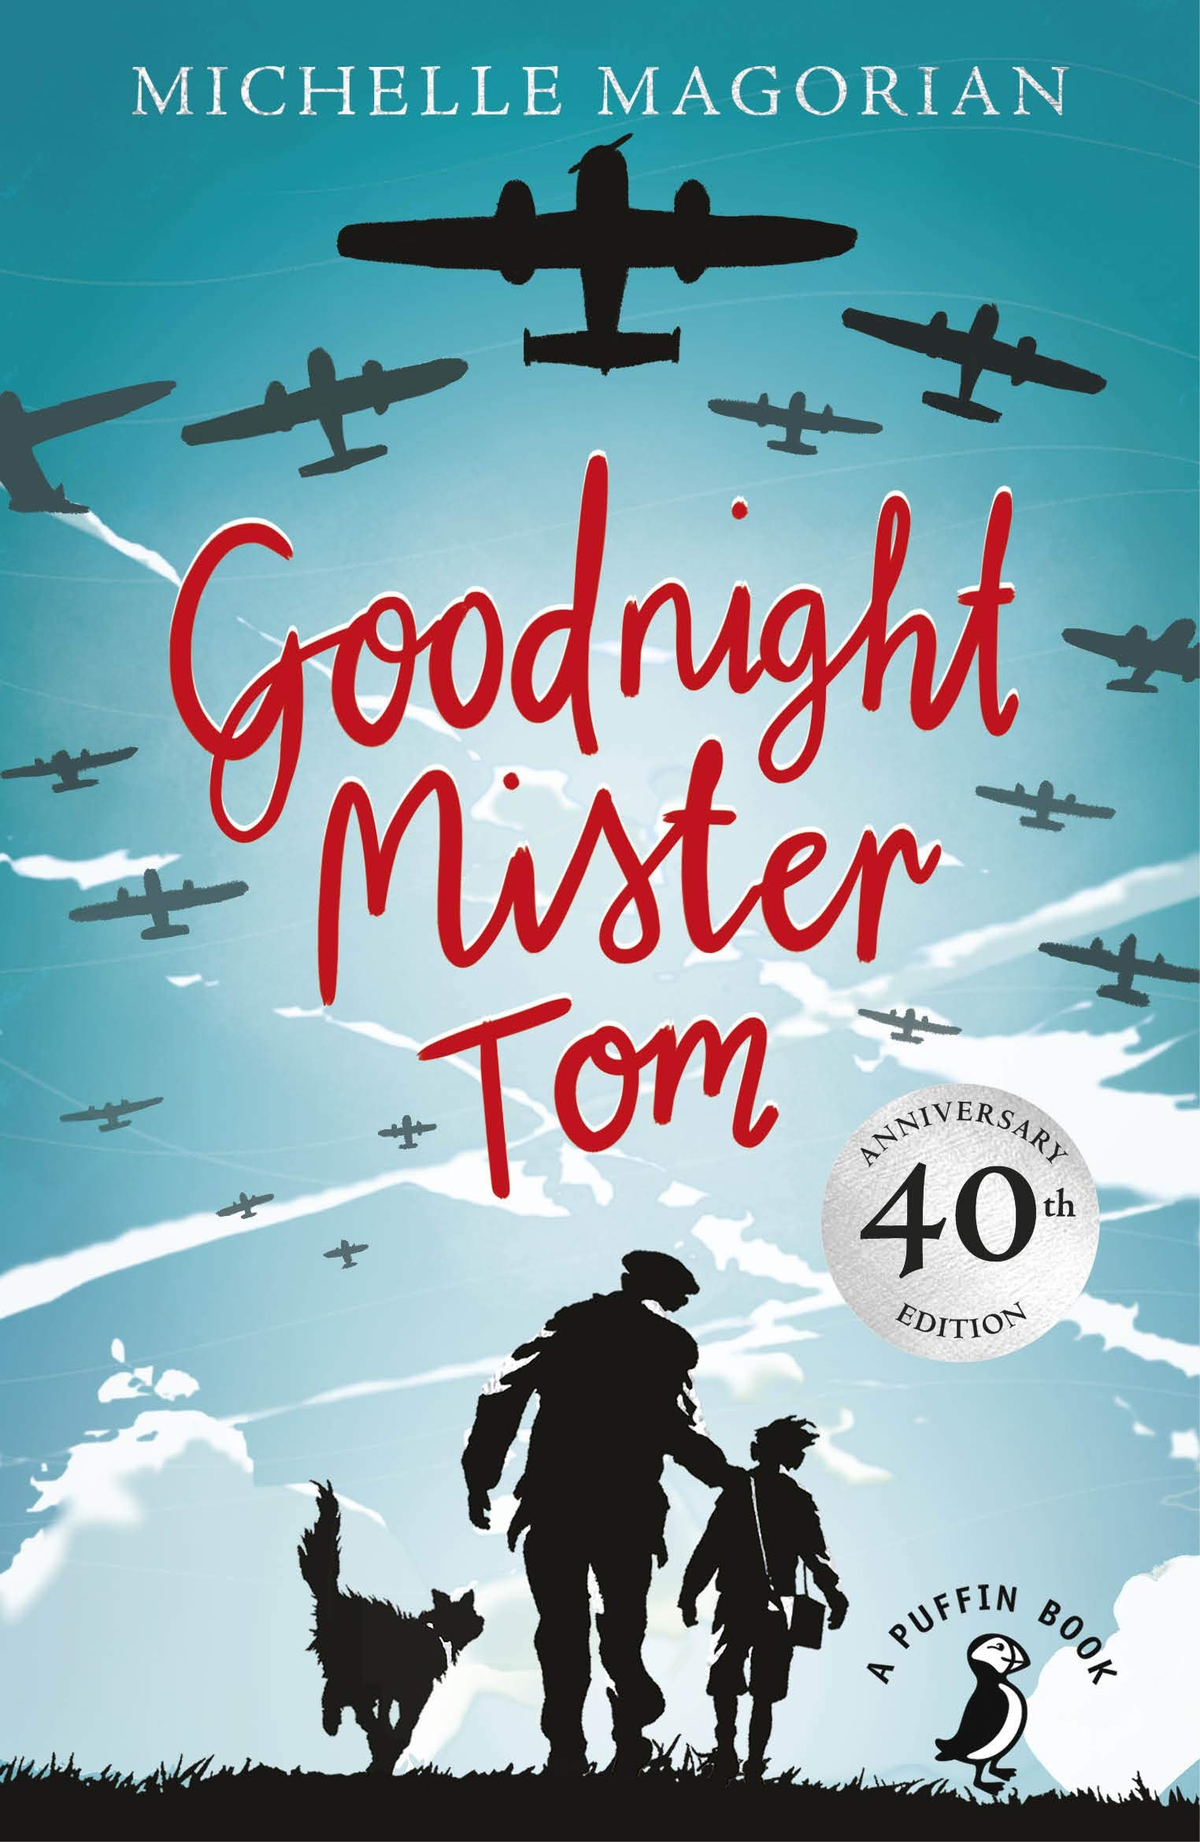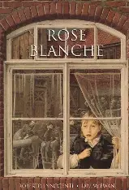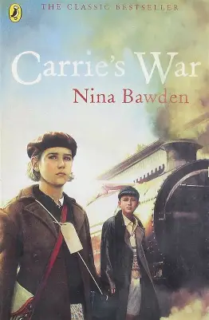 |  | Maths  Learning challenges from White Rose include decimals, percentages and algebra, and some further geometry work to review and extend understanding of shape and its vocabulary.  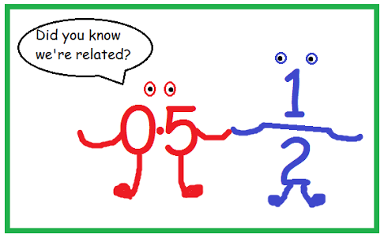
Geography  Why do we say “World Wars I and II”?  Understanding location and mapwork will feature in our humanities lessons, linking geographical Knowledge and understanding to our history topic.  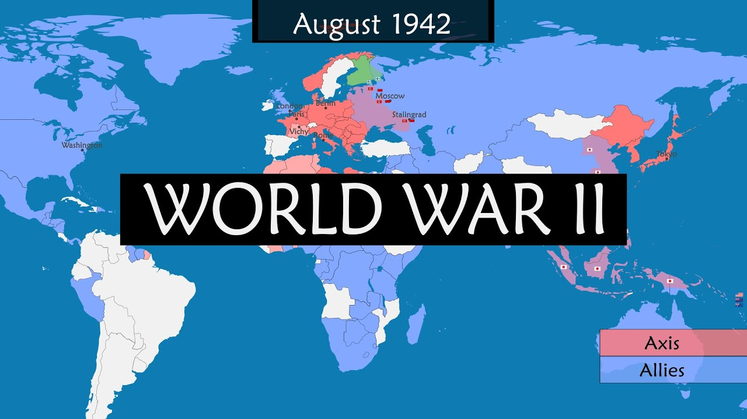 |  | Religious Education  This term we will look in depth at who and what Christians believe Jesus to be. Later in the term we learn about the impact of faith on people’s lives, and there will be an opportunity to explore ideas and beliefs about death and loss.  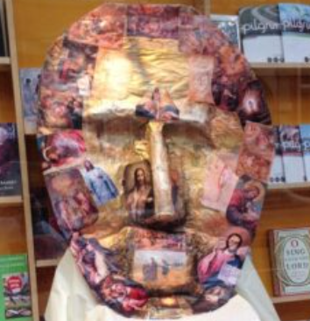 |  | Physical Education  PE lessons will take place on a Monday. This term we are working on the invasion game of netball.  Additionally, during our COAL afternoon, the children will be working on the striking and field game of hockey.  
Computing (COAL afternoon)  We have an exciting topic on programming: variables in a game  This unit explores the concept of variables in programming through games in Scratch.  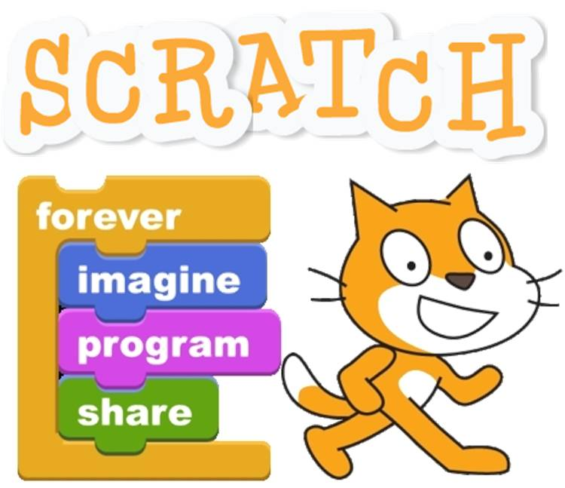 | Music  Children listen to musical interpretations of Spring and compose an original soundscape. The learning is based around Sinfonia Cymru’s Regenerate: Seasons for Change Project which  aims broaden musical tastes, experiences, and knowledge while unlocking creativity.   |  | Science  We begin with a physics topic about light, including understanding light pollution. Later we move onto biology, studying the circulatory system and learning how diet, drugs and lifestyle contribute to health and fitness.  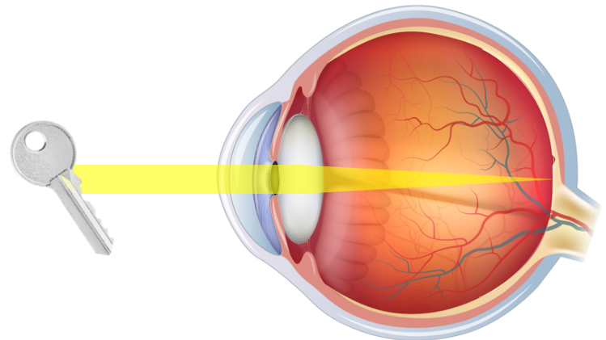  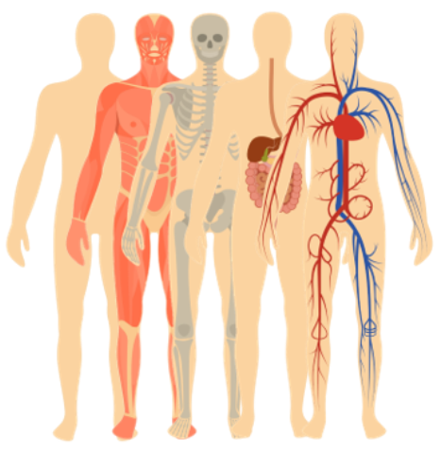
French  Our first theme this term is “Playing Sport”, where children learn new vocabulary and develop understanding of regular verb forms. Next, they learn more about expressing time and use adjectives to describe “My Best Day Ever”.   |  | PSHE  The two puzzles for us to study this term are “Dreams and Goals” and “Healthy Me”.   |  | COAL  On Thursday afternoons our curriculum is fuelled by computing, outdoor and adventurous learning. This term Eagles will be enjoying PE and computing.

Reminders

PE will be on Monday and Thursday afternoons. Please make sure children wear appropriate footwear for PE and come to school dressed in their PE kits.
Homework for maths will be set on Thursdays using our new My Maths platform, to be completed by the following Thursday, when it will be reviewed in class. English homework will be set in Book Club each Monday, to be completed by the following Book Club lesson on the next Monday. Reading books and filled water bottles should be brought to school every day please. Thank you.

