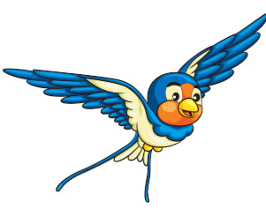
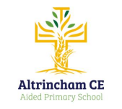
Year 3 Swallows Class

Curriculum Newsletter
Autumn 1 – 2025

Dear parents and carers,

What a brilliant start to Year 3 we have all made! It has been fantastic to see everyone back, all happy and smiling with stories to share, all ready to start in ‘juniors.’ There have been lots of changes already and I am so very proud of how well everyone has settled into the new routines.

Details of our exciting curriculum for this half-term can be found below.

A few reminders:

- Children should wear PE kits on a Monday and Tuesday for this half term only.

- School is a nut free school, this includes no nuts in lunch boxes (no hazelnut spreads) and sweets/chocolates brought in to share.

- The school day is 8.50am to 3.25pm. The gates are locked at 9am and any late comers will need to report to reception. If any children have not been collected by 3.30pm they will be taken to the Ark after school club and charges may apply.

- Reading books, maths work and a piece of English work will be sent home each week. Further details on this will be given following ‘meet the teacher’ on Monday 15th September.

Any queries you can always catch me at morning drop off, afternoon pick-up or leave a message with the office team and I will get back to you as soon as possible.

Best wishes,

Miss Stevens

English  The English Framework at ACE includes daily lessons of English, SPAG (spelling, punctuation and grammar) bursts and reading sessions, both independent and class novel. The children chose the classic ‘The Railway Children’ for their class novel this half term. The English text is called ‘Seal Surfer’ by Michael Foreman.  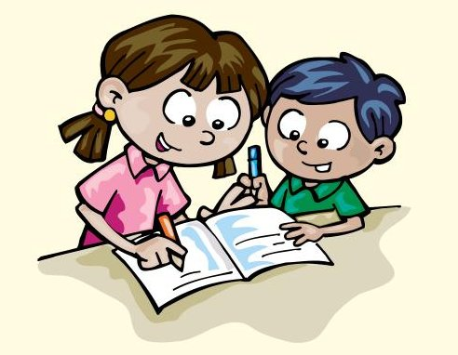 |  | Maths  We follow the White Rose Maths Scheme. Place value, reading, writing, making and partitioning numbers up to 1,000. We will then be moving onto addition and subtraction of 3 digit numbers.  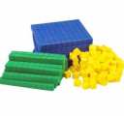
Religious Education  In our RE lessons we will be the Questful RE Scheme. We will be asking the questions Why is harvest celebrated? How and why do Christians and other religions celebrate harvest?  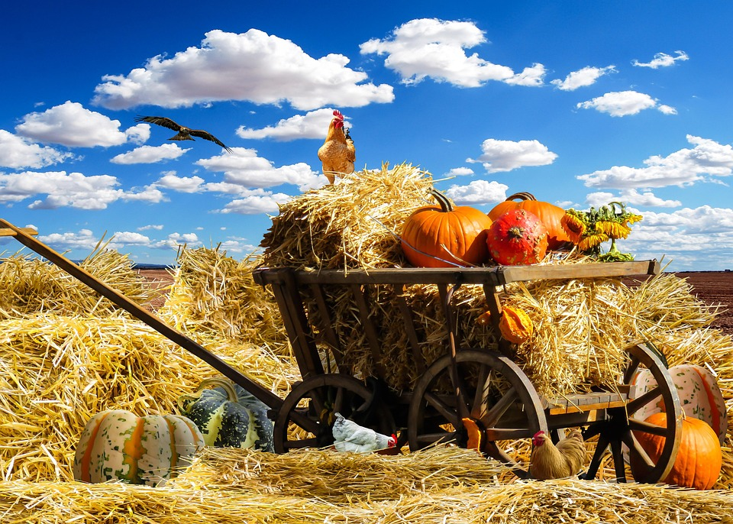 | Science  We follow the White Rose Education scheme for Science and this half term we will be exploring skeletons and movement.  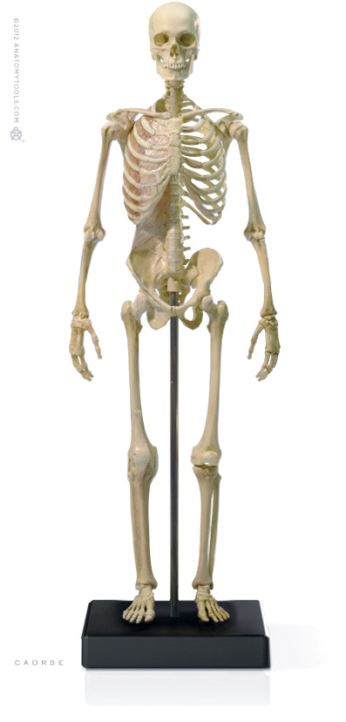 |  | Computing  We will be following the Teach Computing unit of computing systems and networks – connecting computers.  
Geography  We will be asking the key question – what is shaping our world? We will be looking at erosion and deposition.  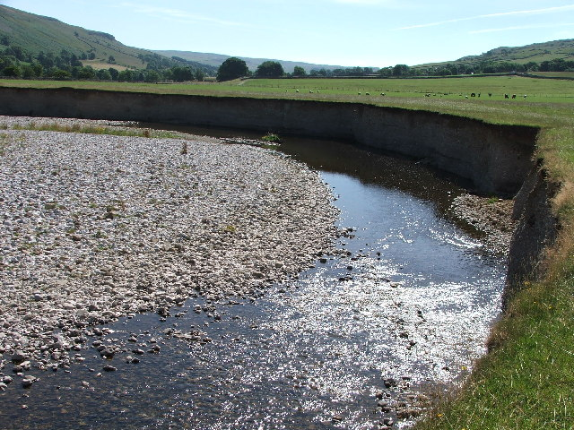 | Music  Our song of the half term is Le Freak by Chic for the children to experience some disco music. We use the Charanga music scheme for weekly lessons.   |  | PE  PE lessons follow the PE Passport scheme. This half term children will be playing handball and taking part in some personal challenges.  
PSHE  We follow the Jigsaw scheme for PSHE. The theme for this half term is ‘Being me in my world’.  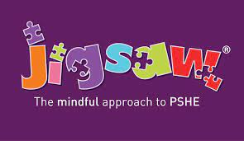 | Worship  Every day your child will be participating in either whole school, Key Stage or class worships.  

