Mrs
Eagles Class (Year 6)
Mrs Taylor
My Favourite Books
Reading is one of the best things ever. As a young child, I loved to get lost in the imaginary worlds of Peter Pan by J.M. Barrie and The Worst Witch by Jill Murphy. Even though I knew those worlds were fictional, I longed to visit them. I still treasure these books today.
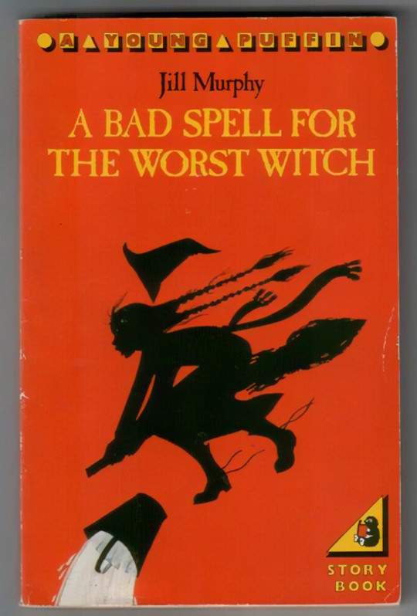
As an adult, I still love to read. A couple of my favourites are below:

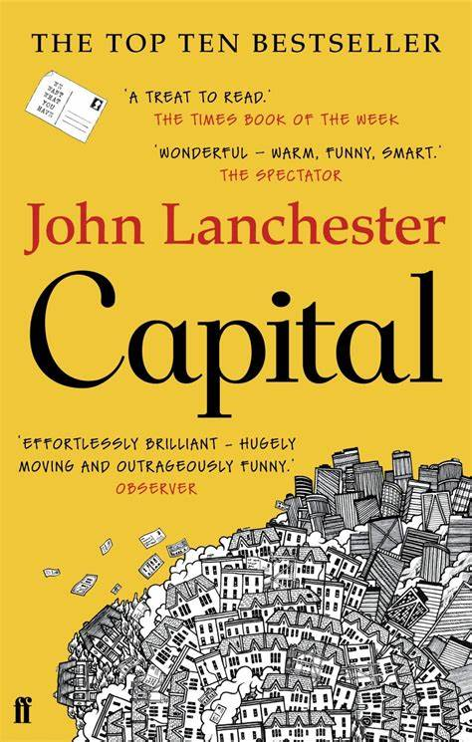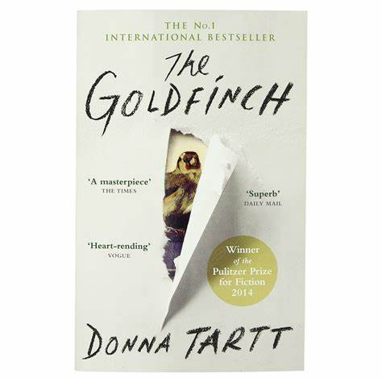
I am looking forward to hearing about your favourite books.
I love history! There is something magical about visiting an historical site and walking wear people walked hundreds or even thousands of years ago!
Another of my hobbies is running. Not only does it keep me fit and healthy, but it also always puts a smile on my face.

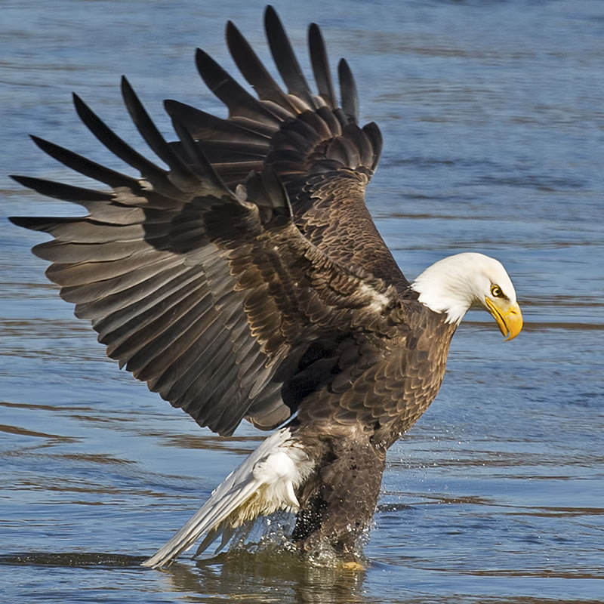

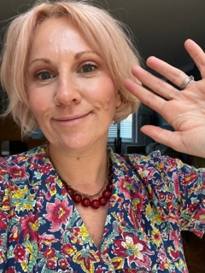
Hello Eagles Class,
My name is Mrs Taylor (you probably already know this!) and I will be your teacher next year. I thought I would introduce myself to you and your families so that I am less of a stranger when September comes.
Your time in Eagles Class will be full of challenge, full of high expectations and full of fun.
From
Mrs Taylor

My Interests
As we are going to be a class ‘team’ together, I thought I’d tell you a bit about myself…
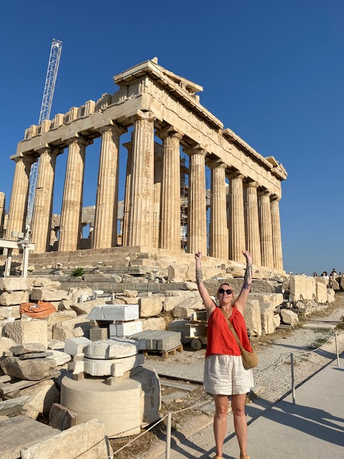
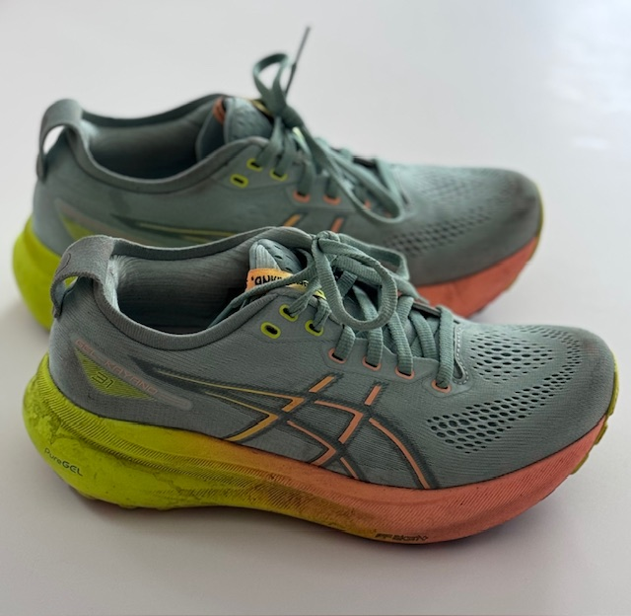
Yes, these are my dirty trainers!

Taylor

