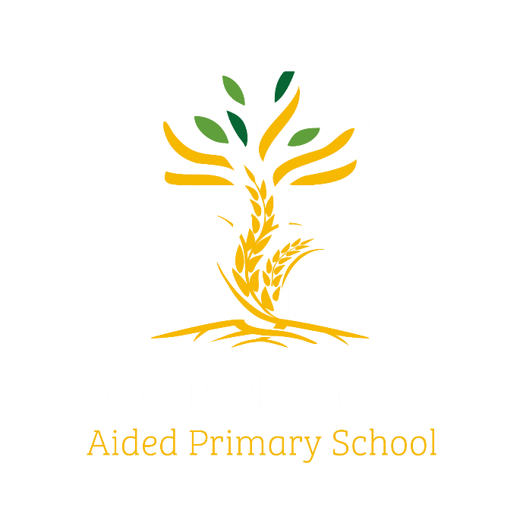
Year 6 Kingfishers

Curriculum Newsletter: Autumn i 2025

Dear Parents and Carers,

I am delighted to welcome Kingfishers class to their final year of primary school – can you believe it? We’ve already had a fantastic start to the year with our visit to Min y Don, and now we have an exciting curriculum to tackle. I look forward to meeting parents and carers in person, in the classroom, to share our vision and objectives for the year ahead when we hold our “Meet the teacher” evening,
Details of our irresistible curriculum for this half-term can be found below.
Remember you can follow our school Instagram feed and see what we are doing!

History  We find out about people who made significant contributions to the Civil Rights movement, and explore its origins and impact.   |  | English  Key Texts:  Jemmy Button byJennifer Uman and Valario Vidali  Sit-In by Andrea Davis Pinkney  The Story of Ruby Bridges by Robert Coles  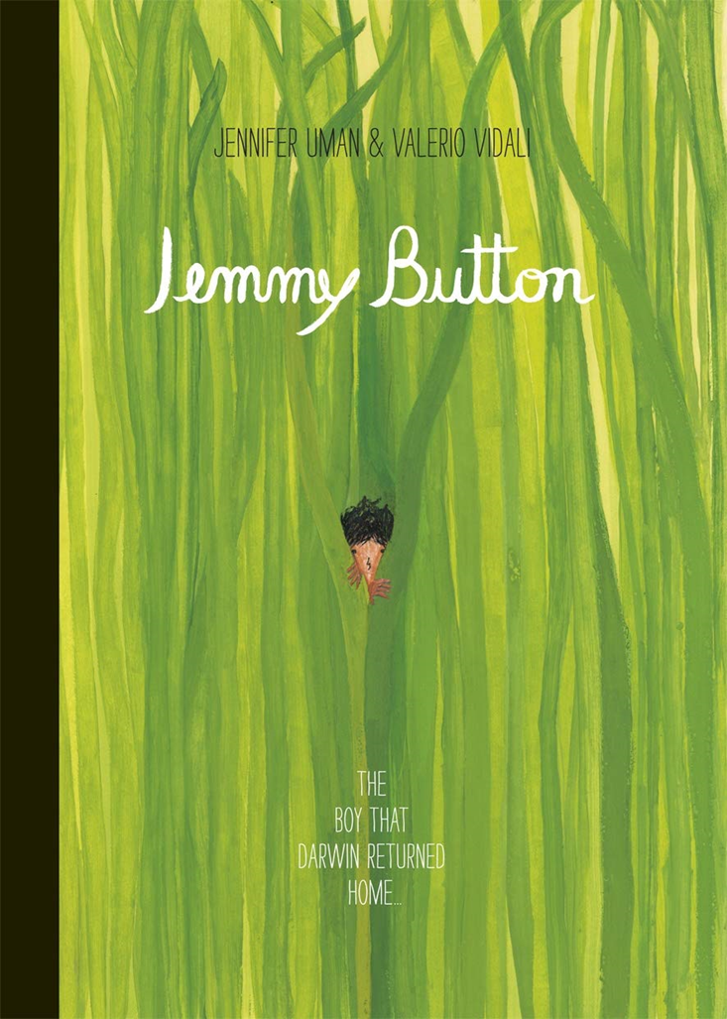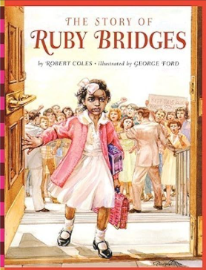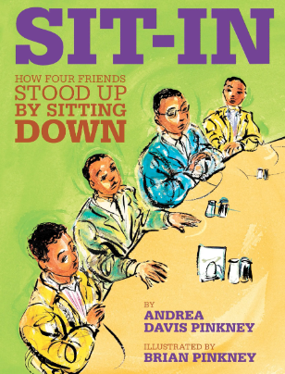  Linking to Black History month in October, we learn to write factual accounts and discursive texts to explore the progress (or lack thereof) of equal rights. |  | Maths  Learning challenges from White Rose include Place Value, Roman Numerals and Four Operations.  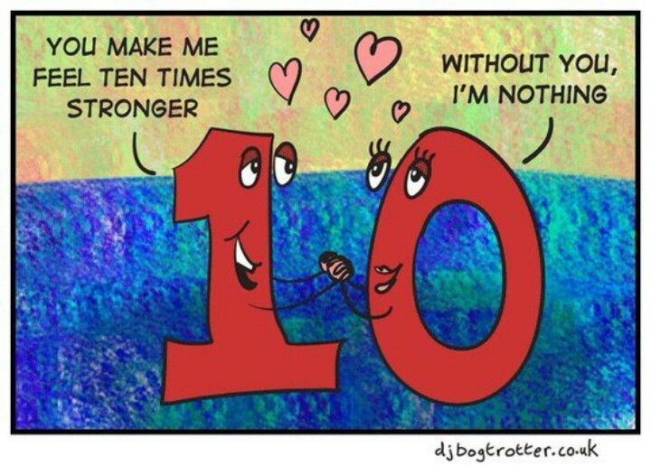
Geography  With strong connections to our history work, we go on an “American Road Trip” to find out about human and physical geographical features of North America.   |  | Religious Education  “Life as a Journey” is our first encounter with Questful RE this year. Children compare their own experience of journeys, then learn how believers’ life milestones can be represented in this way. We also investigate pilgrimages.  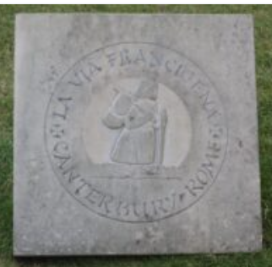 |  | Physical Education  PE lessons will take place on a Wednesday. We begin with games and challenges to build team skills.  Additionally, children will develop a range of outdoor sports and fitness skills during COAL on Thursday afternoons  
Computing (COAL afternoon)  Computing systems and networks - We  explore how data is transferred over the internet. We also look at how the internet facilitates online communication and collaboration, including a focus on online safety and responsible use.   | Music  Singing and listening are at the heart of each lesson as we focus music and technology in our first unit this year. We also try to answer the question, “How does music bring us together?”  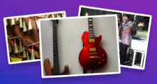 |  | Science  This term we explore the question, “How can animals, plants and microorganisms be identified, grouped and classified?”  We will learn about classification keys for animals and plants. We will investigate how Carl Linnaeus’ system has influenced modern biological science, and how classification has changed since its invention.  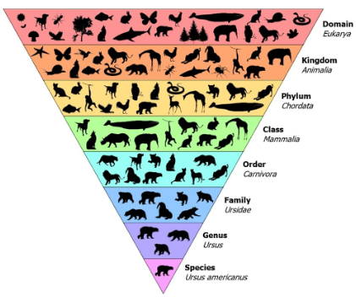
French  We will refresh our memories of French vocabulary, use of verbs and revise simple conversation and greetings.   |  | PSHE  “Being Me in My World” puzzle from our Jigsaw programme  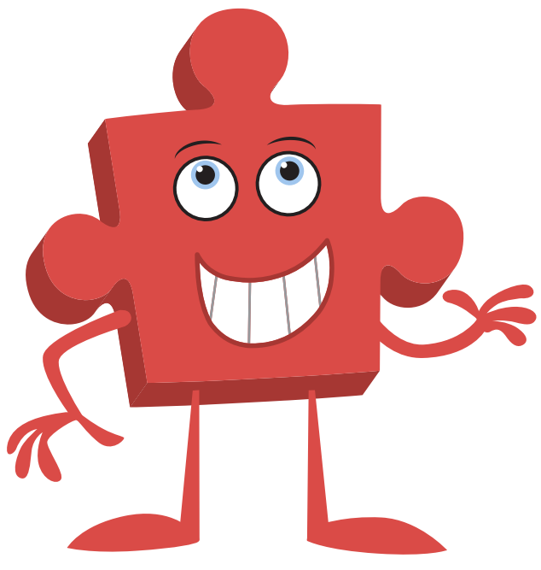 |  | COAL  On Thursday afternoons our curriculum is fuelled by computing, outdoor and adventurous learning. This term Kingfishers will be enjoying PE and computing.

Reminders

PE will be on Wednesday and Thursday afternoons. Please make sure children wear appropriate footwear for PE and come to school dressed in their PE kits.
Homework for maths will be set on Thursdays, to be completed by the following Thursday, when it will be reviewed in class. English homework will be set in Book Club each Monday, to be completed by the following Book Club lesson on the next Monday. Reading books and filled water bottles should be brought to school every day please. Thank you.



