 aceeagles25 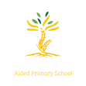
Year 6 Eagles

Curriculum Newsletter: Spring ii 2025

Dear Parents and Carers,

Unbelievably we are now half way through Year 6! We look forward to working hard this term, both preparing for SATs and exploring our broad and exciting foundation curriculum.
Details of our irresistible curriculum for this half-term can be found below.
Remember you can follow Instagram, aceeagles25 and see what we are doing!

English  Key Texts:  Sky Chasers  by Emma Carroll  This is an historical novel which takes an unusual perspective on a key moment from history.  Children will review knowledge of history and geography as they read extracts from this novel and then use them to inspire some autobiographical writing.  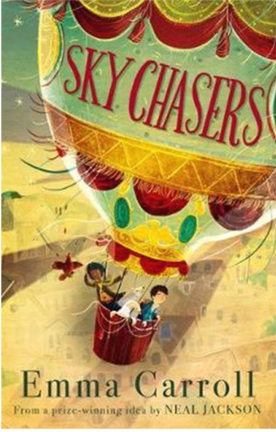 | Geography  We will learn about more of the different biomes across the globe, including Savannah and Polar regions.   |  | Maths  Our maths topics this half term will be Fractions, decimals and percentages; Area, perimeter and volume and Statistics.  
 | Religious Education  Our topic this term is a sensitive one as it explores difficult issues which affect us all. The themes are “Loss, Death and Christian Hope”. It includes exploration of the Easter story as well as looking at different world views.   |  | Physical Education  PE lessons will take place on a Friday. Sam will be coaching some movement and dance lessons. Additionally, children will develop a range of team sport skills during COAL afternoons.  
Computing  We have an exciting unit of work on 3D modelling this term. Children will learn to design and construct models for specific purposes, allowing them to get creative!  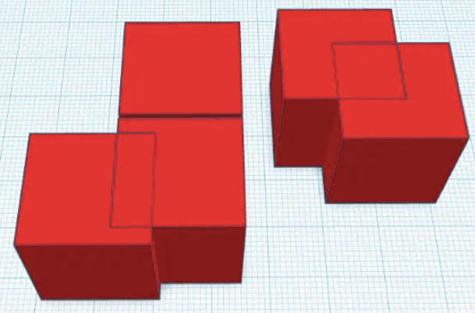 |  | Science  Building on learning the children did in Year 4 about systems in the human body, we will investigate the circulatory system and then learn more about the impact of diet, drugs and lifestyle on our bodies.  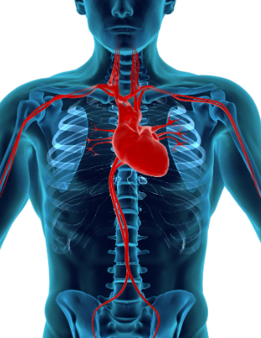
French  Madam Adam will continue to teach French on Monday mornings.   | PSHE  The next puzzle from our Jigsaw programme is “Healthy Me”. The children will learn about ways they can take responsibility for their health, which includes mental health and wellbeing.   |  | COAL  On Thursday afternoons our curriculum is fuelled by creative, outdoor and adventurous learning. This term Eagles will continue with PE, and music. Our music lessons are taught by a specialist teacher from Trafford Music Service, giving children the opportunity to learn a musical instrument.  

Reminders

PE will be on Thursdays and Friday. Please make sure children have appropriate footwear for PE and come to school dressed in their PE kits.
Homework for maths will be set on Thursdays, to be brought back to school the following Thursday, when it will be reviewed in class. English homework will be set in Book Club each Friday, to be completed by the following Book Club lesson on the next Friday. Reading books and filled water bottles should be brought to school every day please. Thank you.



