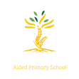
Year 6 Eagles

Curriculum Newsletter: Spring i 2025

Dear Parents and Carers,

Happy New Year! I hope you have all enjoyed a relaxing Christmas break with your families. We look forward to a new term of learning.
Details of our irresistible curriculum for this half-term can be found below.
Remember you can follow our Instagram feed and see what we are doing!

English  Key Texts:  The Selfish Giant  by Oscar Wilde  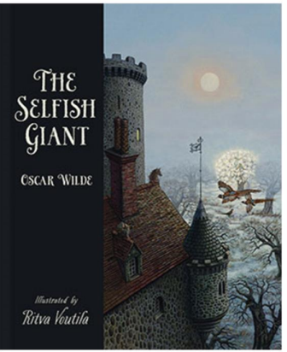  The Happy Prince and Other Tales  by Oscar Wilde  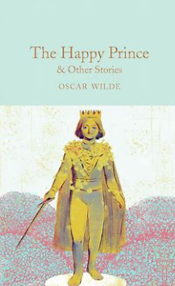  If I Were A Giant – a poem by Jackie Hosking | Geography  We will learn about different climate zones and biomes across the globe.  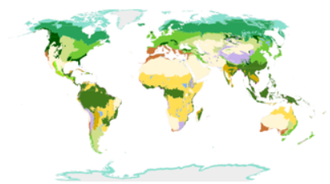 |  | Maths  Learning challenges from White Rose include Ratio, Algebra and further work on decimals.  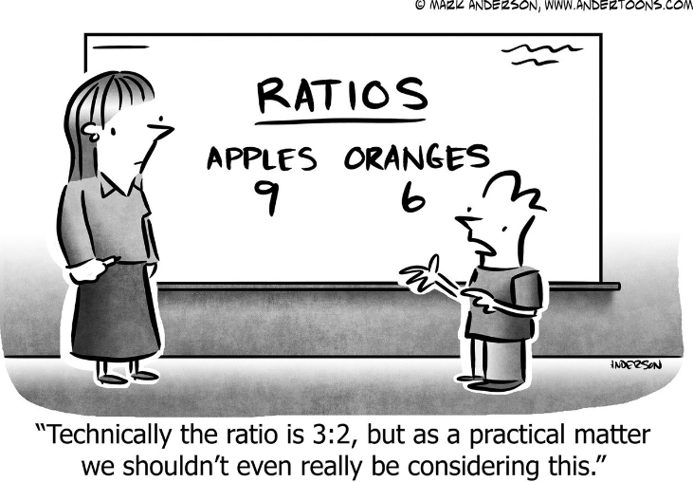
 | Religious Education  This term we will be learning about some inspirational women in the Old Testament of the Bible.  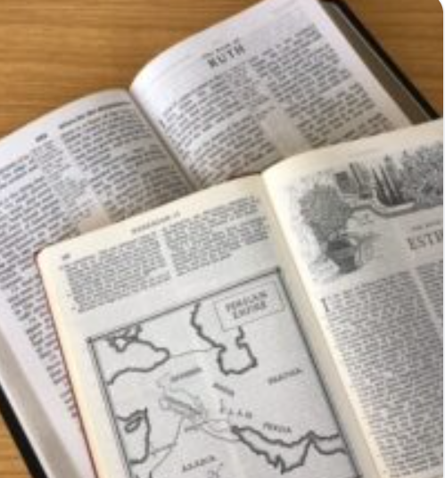 |  | Physical Education  PE lessons will take place on a Friday. Sam will be coaching some dance and gymnastic lessons. Additionally, children will develop a range of team sport skills during COAL afternoons.  
Computing  Pupils will create their own vector drawings. They will learn how to use different drawing tools to help them create, group and duplicate images to build into more complex pieces of work.   |  | Science  We have a physics topic this half-term, exploring the key question, “How does light travel, and how does it illuminate the world around us?”  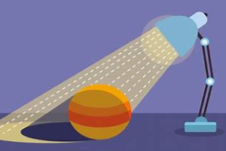
French  Our knowledge of grammar is progressing and we will develop our ability to understand, speak and write simple sentences on a range of topics.   | PSHE  “Dreams and Goals” puzzle from our Jigsaw programme. This focuses motivation, steps to success and building resilience to cope when goals seem hard to attain.  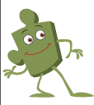 |  | COAL  On Thursday afternoons our curriculum is fuelled by creative, outdoor and adventurous learning. This term Eagles will take part in PE, and music. Our music lessons are taught by a specialist teacher from Trafford Music Service, giving children the opportunity to learn a musical instrument.  

Reminders

PE will be on Thursdays and Friday. Please make sure children have appropriate footwear for PE and come to school dressed in their PE kits.
Homework for maths will be set on Thursdays, to be brought back to school the following Thursday, when it will be reviewed in class. English homework will be set in Book Club each Friday, to be completed by the following Book Club lesson on the next Friday. Reading books and filled water bottles should be brought to school every day please. Thank you.



