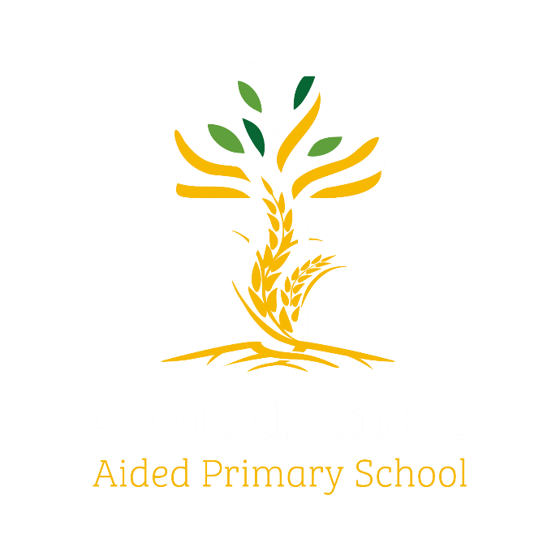
Year 6 Eagles

Curriculum Newsletter: Autumn ii 2024

Dear Parents and Carers,

Welcome back to our second Autumn half-term.
Details of our irresistible curriculum for this half-term can be found below.
Our Instagram accounts are now up and running, so you can follow our class feed to see what we are doing!

History  What was the industrial revolution and how do we see its legacy around Manchester? We continue to learn about the Victorian era and the lasting impact we see in our local area,  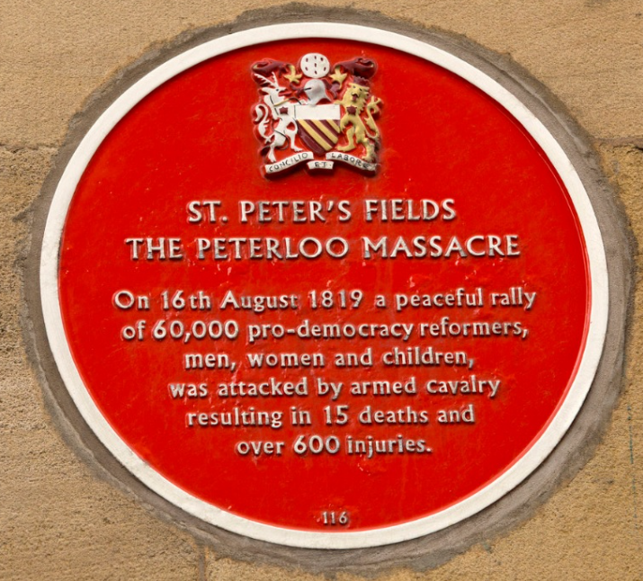 | English  Key Texts:  We will be studying a gorgeous book that tackles an important environmental issue. The children will write their own information texts to highlight the plight of endangered animals.  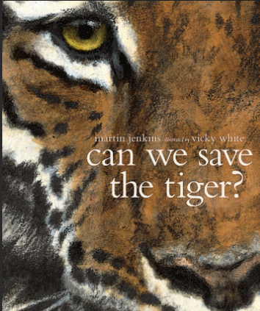 |  | Maths  Learning challenges from White Rose include work on calculating with fractions and using this in the context of measurement.  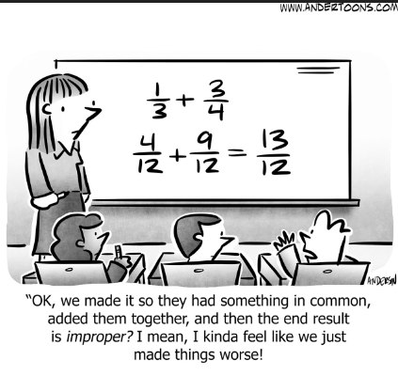
Geography  Mapwork and links to human geography milestones to provide context for deeper understanding of the Industrial Revolution.  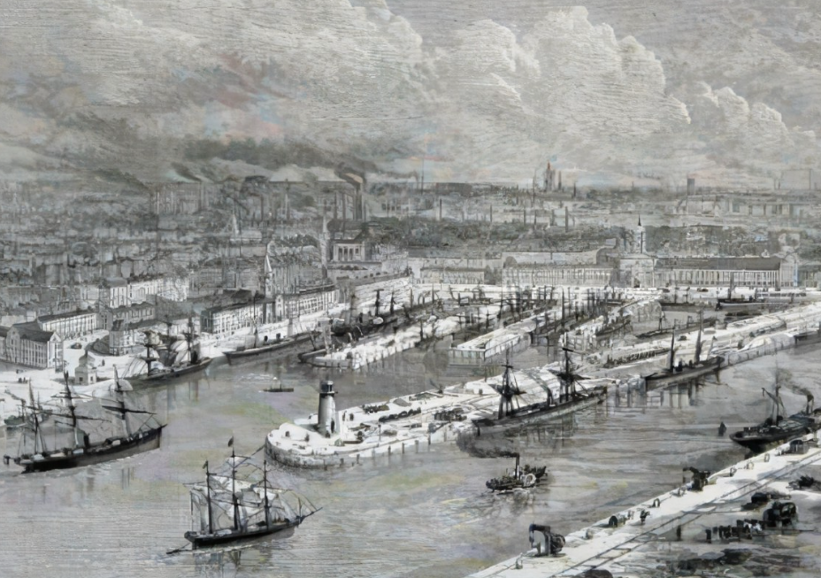 | Religious Education  We begin by learning about the Hindu festival of Diwali. Then, as we approach the joyful church seasons of Advent and Christmas, we will find out how Christmas is celebrated by Christians around the world.  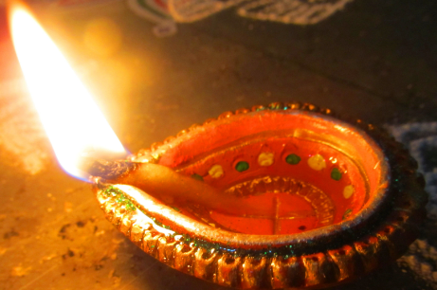 |  | Physical Education  PE lessons will take place on a Friday, with our coaching staff.  Additionally, children will develop a range of outdoor skills during COAL on Thursday afternoons  
Computing  Pupils will be learning about data and information. This unit looks at how a flat-file database can be used to organise data in records. Pupils will use tools within a database to order and answer questions about data. They will create graphs and charts from their data to help solve problems. They will use a real-life database to answer a question, and present their work to others.   |  | Science  Electricity and renewable energy are our topics for the next seven weeks. This will include drawing and interpreting circuit diagram, learning about and experimenting with electrical components.  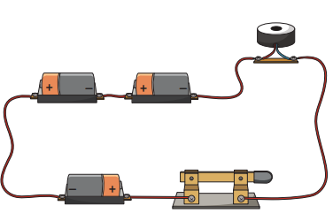
French  We will develop understanding of French grammar and vocabulary, responding verbally and writing sentences.   | PSHE  The next puzzle from our Jigsaw programme is  called “Celebrating Difference” .  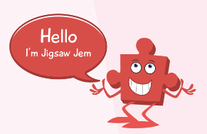 |  | COAL  On Thursday afternoons our curriculum is fuelled by creative, outdoor and adventurous learning. This term Eagles will be in forest school. Please remember to send waterproof clothing and footwear.

Reminders

PE will be on Friday mornings. Please make sure children have appropriate footwear for PE and come to school dressed in their PE kits.
Homework for maths will be set on Thursdays, to be completed by the following Thursday, when it will be reviewed in class. English homework will be set in Book Club each Friday, to be completed by the following Book Club lesson on the next Friday. Reading books and filled water bottles should be brought to school every day please. Thank you.



