
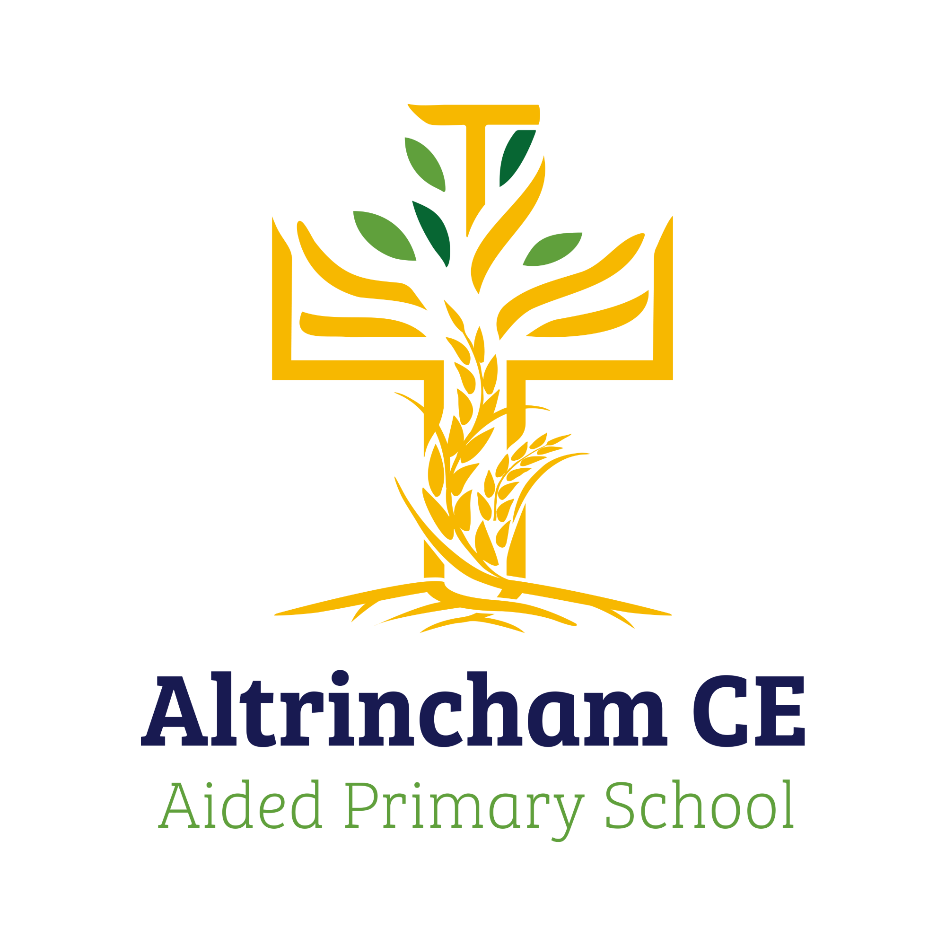
Year 4 Finches.

@ACEFinches

Curriculum Newsletter: Autumn 2- 2024

Dear Parents and Carers,

Welcome back! We hope you had a lovely half term and had lots of fun! We are looking forward to a jam packed half term with very exciting learning. Details of our irresistible curriculum for this half-term can be found below.
You can now follow our Instagram and see what we are doing!

History  Our history key question is ‘How can we rediscover the wonders of Ancient Egypt’  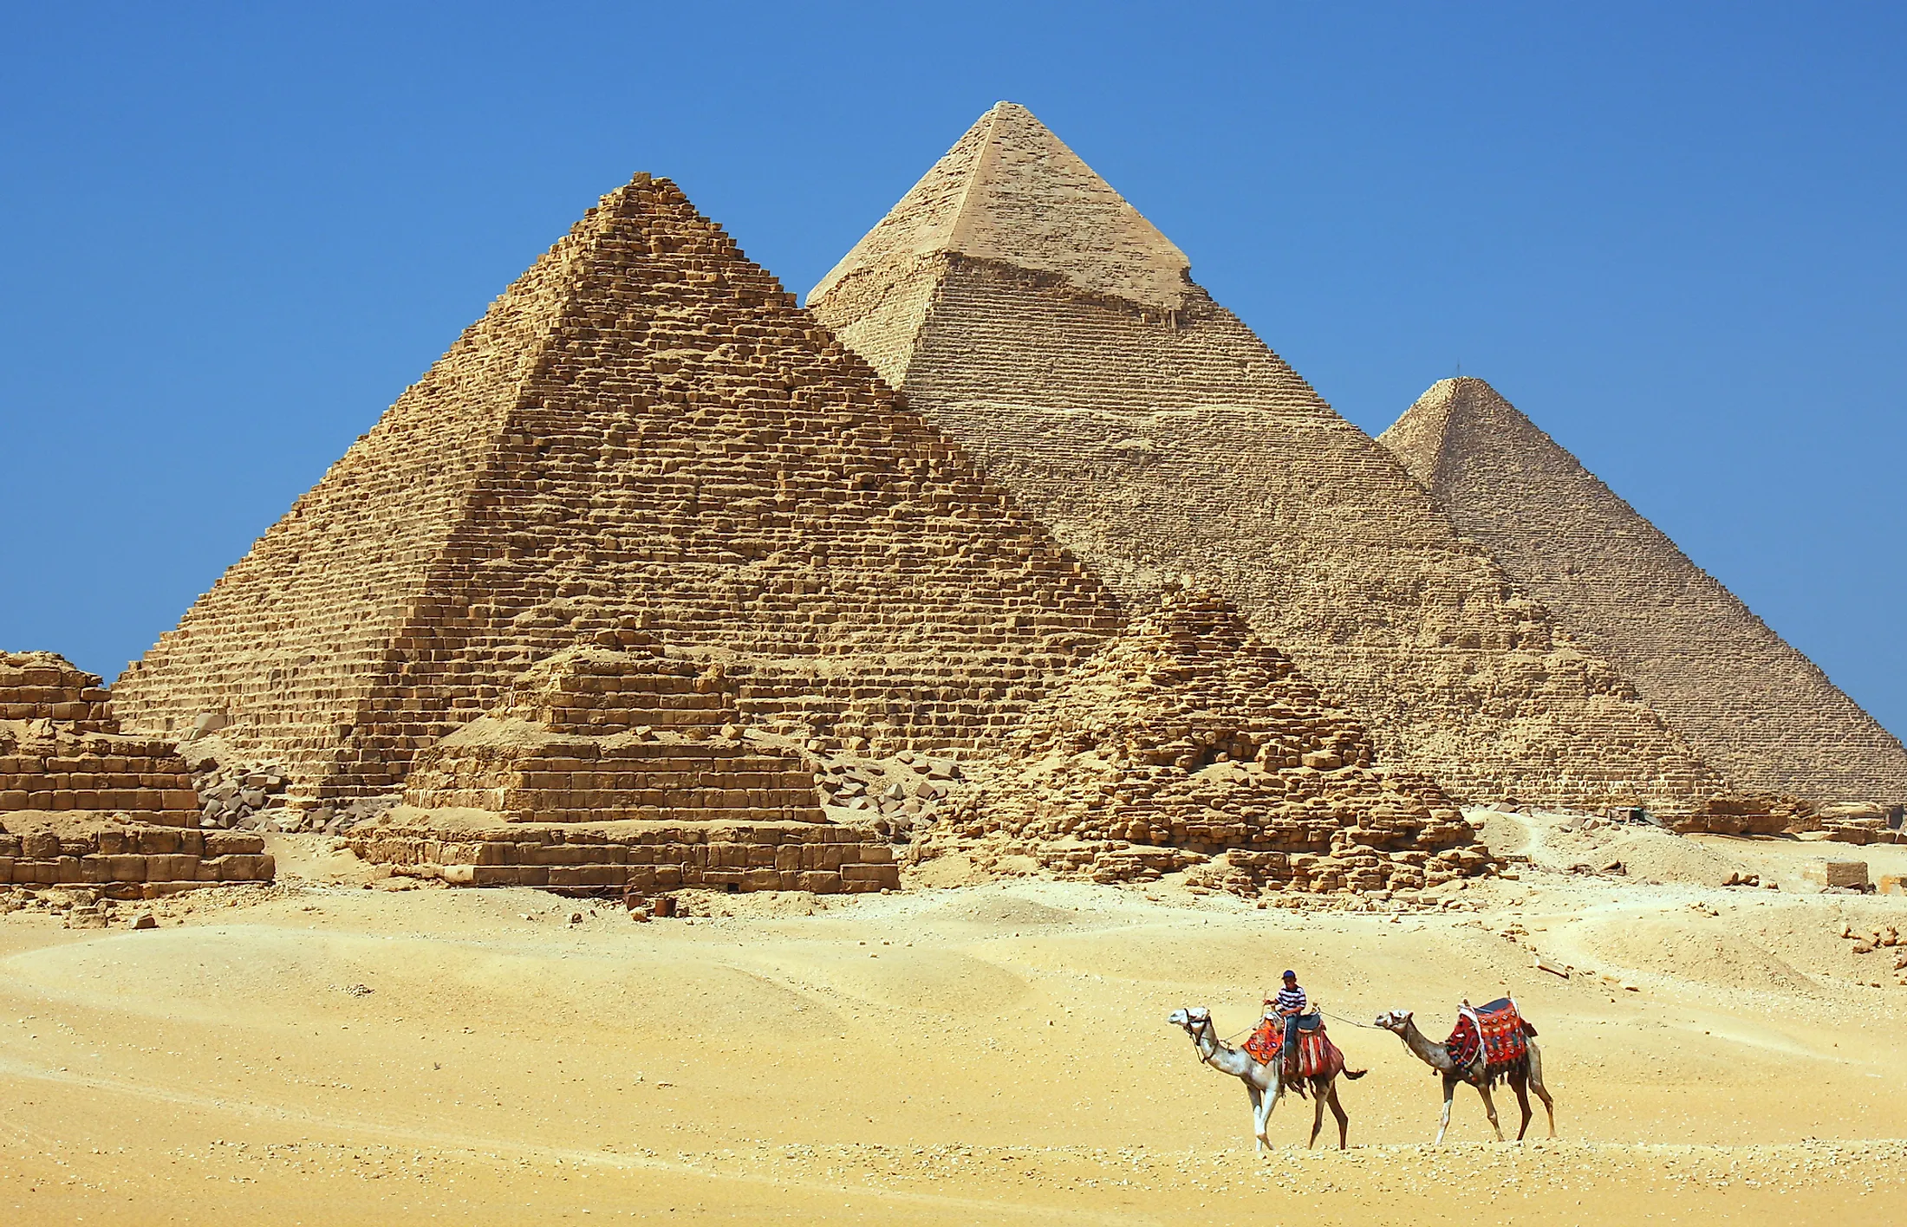 | English  Key Text: Leon and the Place Between  by Angela McAllister  Our English focus will be a fiction piece of writing. We will be diving into a new key text, ‘Leon and the Place Between’ by Angela McAllister which is an engaging picture book. We will be building on our mastery skills as we plan, sequence, section and write. The outcome of this topic will be a secret diary of what happened in The Place Between from Leon’s point of view.  Leon and the Place Between is about a boy who wants to prove that magic exists. He volunteers to be in Abdul Kazam’s magic show and gets transported to a mysterious world.  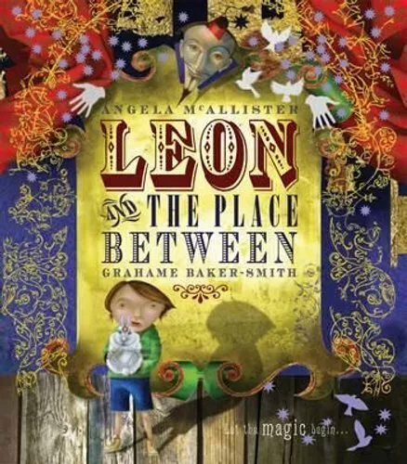 | Maths  This half term, White Rose maths focuses on multiplication and division. Please continue to access TT Rock Stars, in preparation for the times table check at the end of the year.  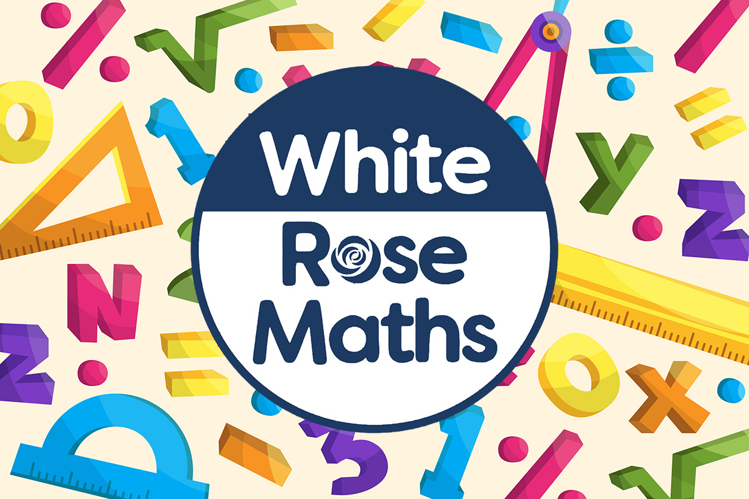
Religious Education  The key questions are as follows:  Why is Jesus described as the light of the world?  Why is light such a powerful symbol?  Is light a good metaphor for Jesus? |  | Physical Education  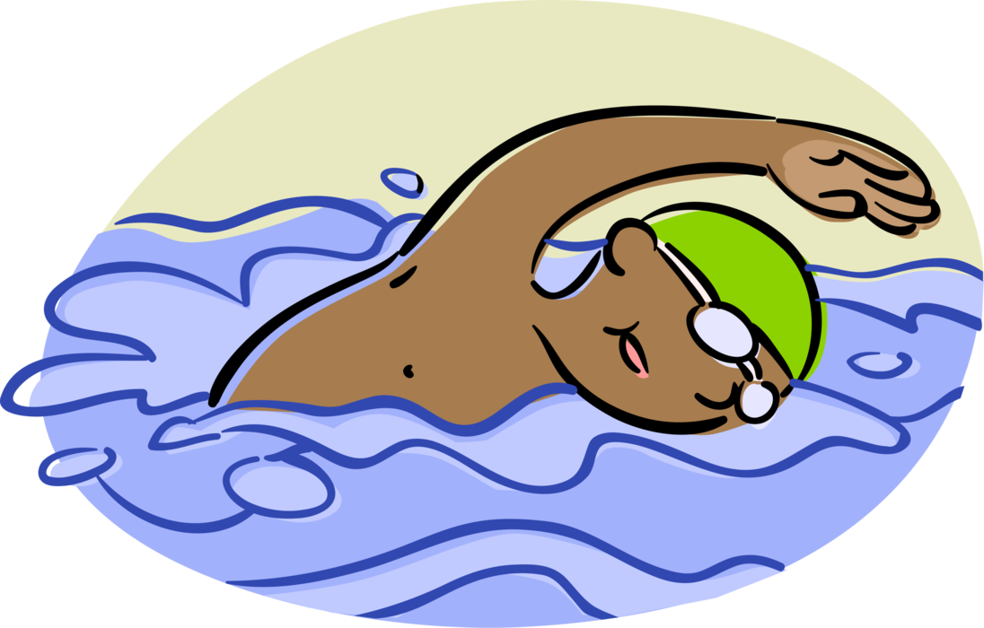  The children will have swimming lessons, every day, for at least 3 weeks.
Computing  The children will identify input and output devices required to work with sound digitally. They will discuss ownership of digital audio and the copyright implications of duplicating the work of others. The children will record and edit their own podcast.  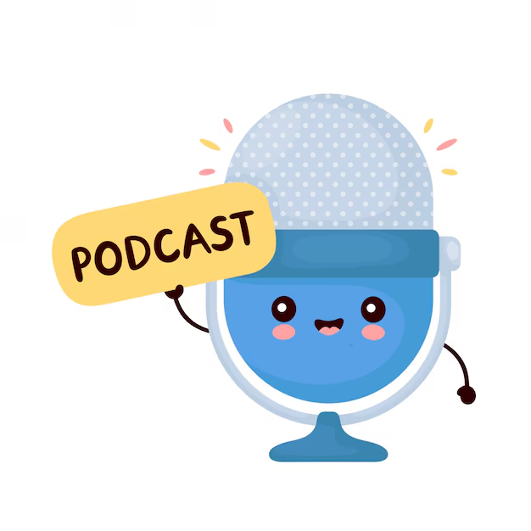 | Science  Our topic is states of matter.  Through a range of investigations, the children will learn that materials and objects can be grouped into solids, liquids and gases. They look at the properties of solids, liquids and gases and relate these to the common uses of materials.  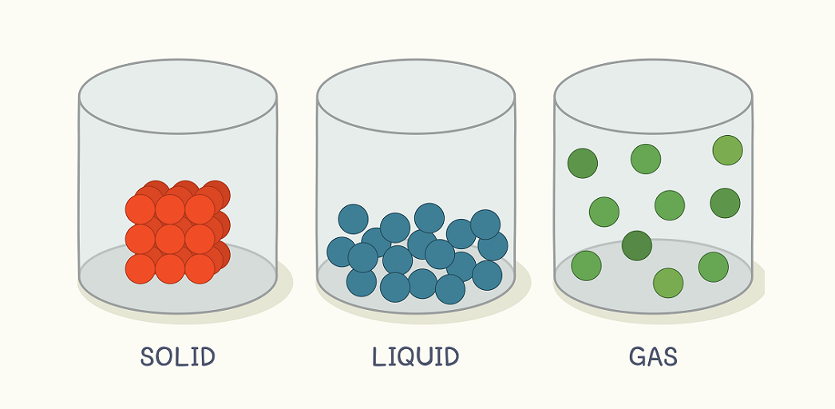
French  We will practise conversational phrases to allow us to engage in short dialogue with each other. We will respond to instructions given in French as well as using masculine and feminine nouns. | PSHE  “Celebrating difference” puzzle from our Jigsaw programme. | COAL  On Tuesday afternoons the children have a fantastic opportunity for creative, outdoor and adventurous learning.

Reminders

Our COAL afternoon is Tuesday. The groups will stay the same as Autumn 1. The children must bring their swimming kits in every day. If possible, please send extra uniform, in case the children accidentally wet their clothing.

Homework for maths and English will be set on Fridays, to be completed by the following Friday. Reading books should be in school every day please.

I am looking forward to a fantastic half term, thank you in advance for all your support in these matters.

Miss Flynn

