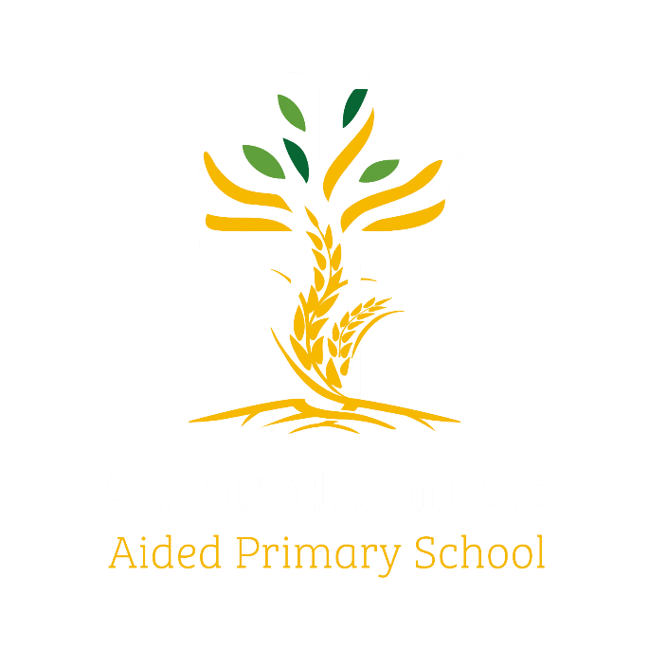
Year 6 Eagles

Curriculum Newsletter: Autumn i 2024

Dear Parents and Carers,

I am delighted to welcome Eagles class to the new school year. Following our summer break, we are all raring to go with our exciting units of learning. I look forward to meeting parents and carers in person, in the classroom, to share our vision and objectives for the year ahead when we hold our “Meet the teacher” evening,
Details of our irresistible curriculum for this half-term can be found below.
Remember you can follow our Instagram feed and see what we are doing!

History  What was the industrial revolution and how do we see its legacy around Manchester?  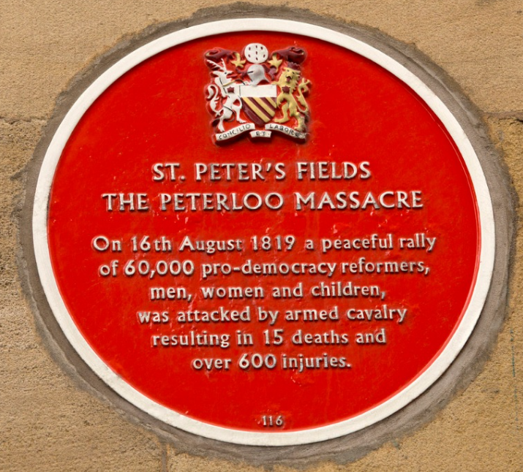 | English  Key Texts:  Fantastically Great Women by Kate Pankhurst  by Tony Walsh  Mill Girl by Sue Reid  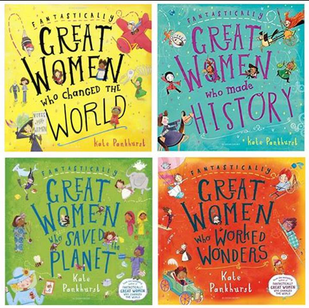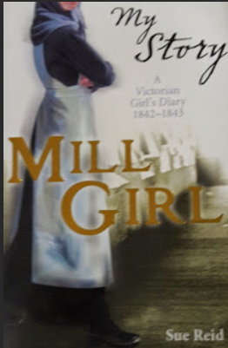 | Maths  Learning challenges from White Rose include Place Value, Roman Numerals and Four Operations  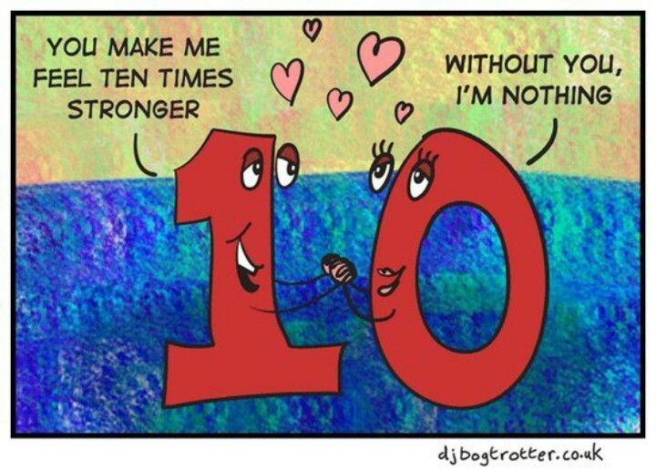
Geography  Mapwork and links to human geography milestones to provide context for deeper understanding of the Industrial Revolution.  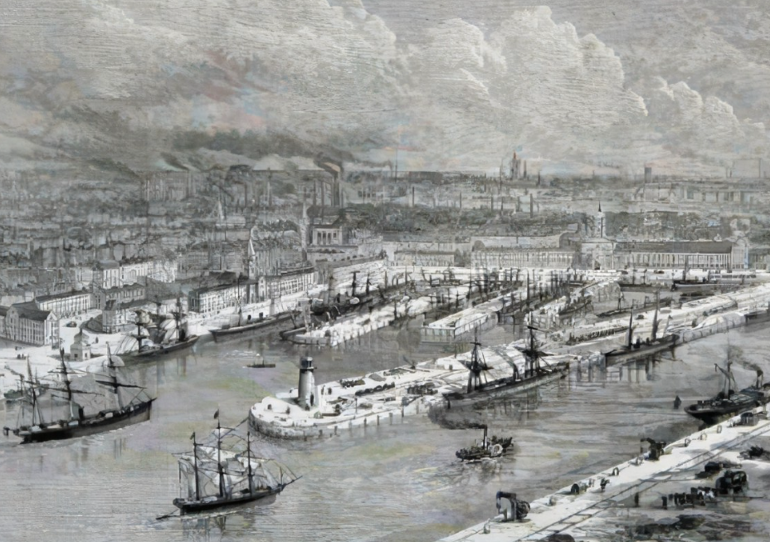 | Religious Education  We will explore Christian learning from the Bible and find out why holy texts are important.  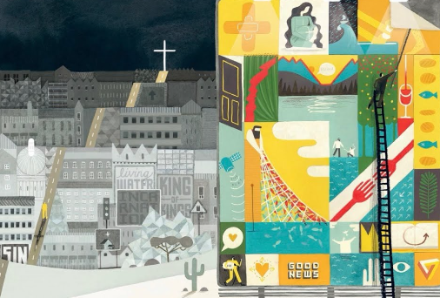 | Physical Education  PE lessons will take place on a Friday, with our coaching staff.  Additionally, children will develop a range of outdoor skills during COAL on Wednesday afternoons  
Computing  Pupils will be learning about video production. This unit will give pupils the opportunity to learn how to create short videos in groups. As they progress through this unit, they will be exposed to topic-based language and develop the skills of capturing, editing, and manipulating video | Science  This term we explore the question, “How can animals, plants and microorganisms be identified, grouped and classified?”  We will learn about classification keys for animals and plants. We will investigate how Carl Linnaeus’ system has influenced modern biological science, and how classification has changed since its invention.  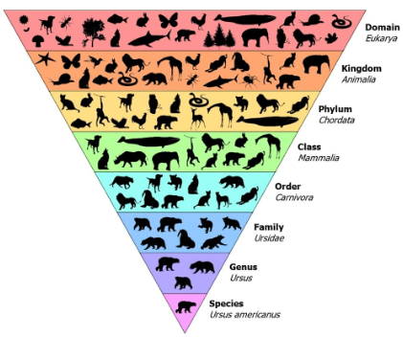
French  We will refresh our memories of French vocabulary, use of verbs and revise simple conversation and greetings.   | PSHE  “Being Me in My World” puzzle from our Jigsaw programme  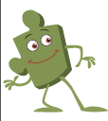 | COAL  On Wednesday afternoons our curriculum is fuelled by creative, outdoor and adventurous learning. This term Eagles will be in forest school. Please remember to send waterproof clothing and footwear.

Reminders

PE will be on Friday mornings. Please make sure children have appropriate footwear for PE and come to school dressed in their PE kits.
Homework for maths will be set on Thursdays, to be completed by the following Thursday, when it will be reviewed in class. English homework will be set in Book Club each Friday, to be completed by the following Book Club lesson on the next Friday. Reading books and filled water bottles should be brought to school every day please. Thank you.



