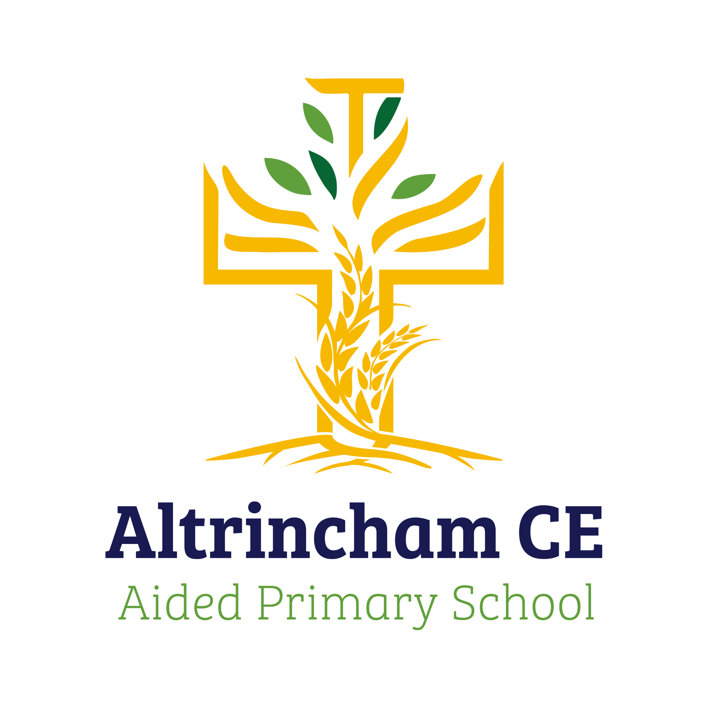
Year 4 Finches

Curriculum Newsletter: Autumn 1- 2024

Dear Parents and Carers,

Welcome back! I hope you had a lovely summer filled with fun! I am looking forward to a jam packed half term with very exciting learning. Details of our irresistible curriculum for this half-term can be found below.

Geography  How do map makers describe where places are? As we explore this key question, we will be labelling locations, understanding the eight points of a compass and finding four figure grid references. Children will practice atlas and map skills as well of learning how to correctly use navigational language. | English  Our English focus will be a fiction piece of writing. We will be diving into a new key text, ‘Gorilla’ by Anthony Browne which is an engaging picture book. We will be building on our mastery skills as we plan, sequence, section and write. The outcome of this topic will be to write an animal adventure story.  Our new key text follows the story of Hannah. She is a girl who loves gorillas, but has never seen one, because her father is too busy to take her to the zoo. For her birthday, Hannah receives a toy gorilla and is extremely disappointed. Luckily, something extraordinary happens.  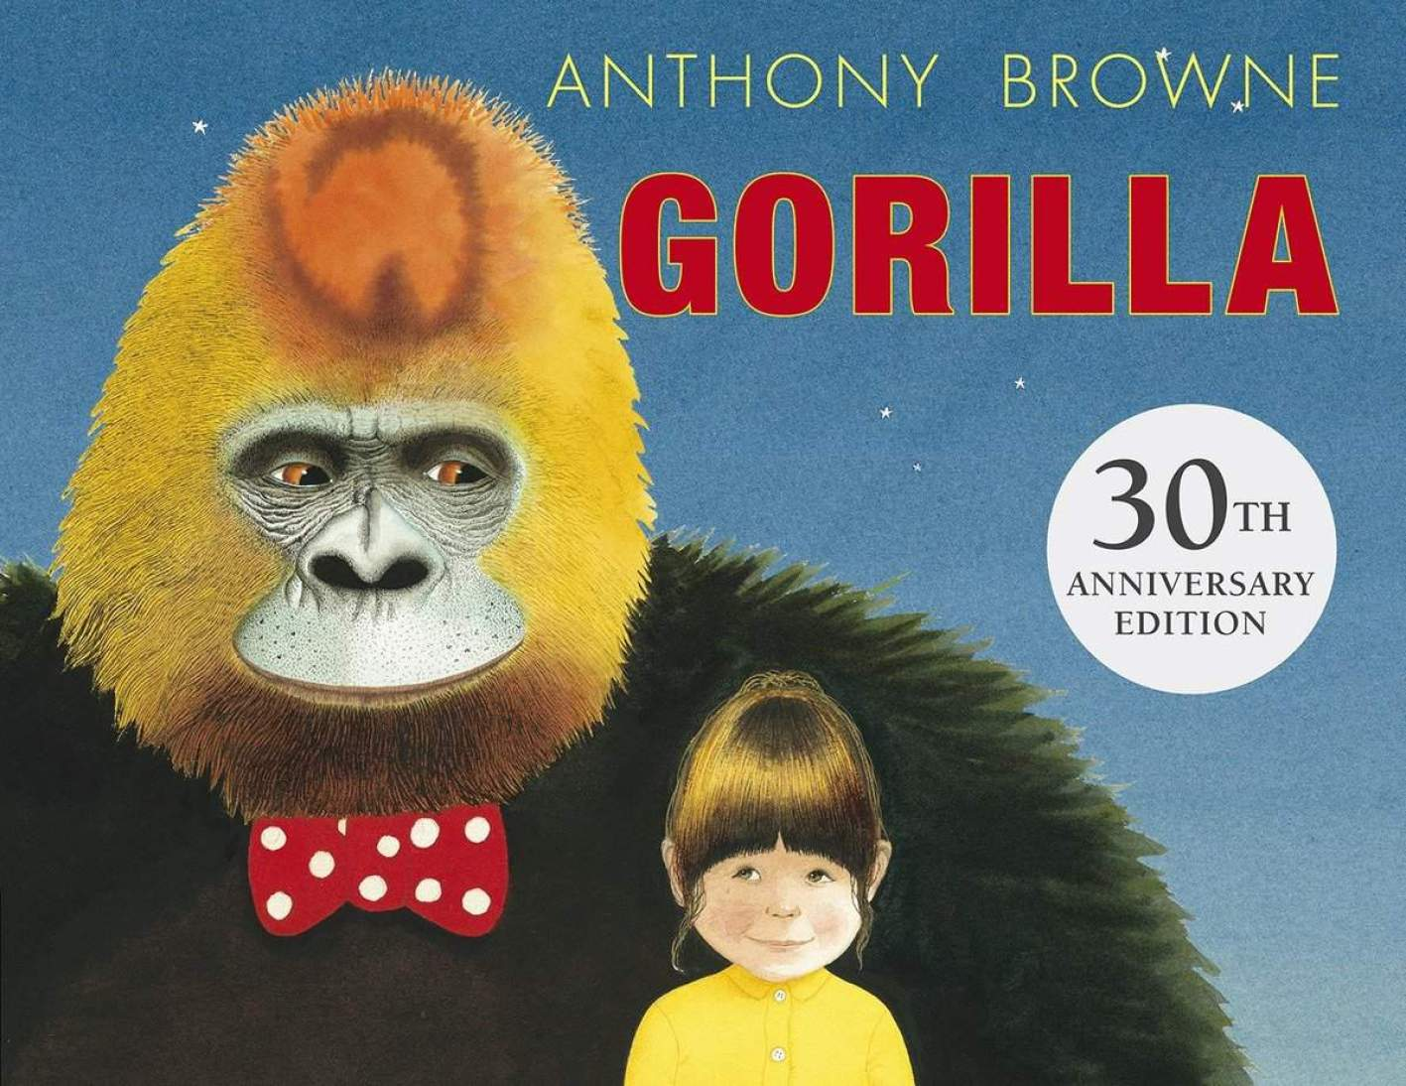 |  | Maths  The half term, White Rose maths begins with a focus on place value. We will then move on to addition and subtraction.  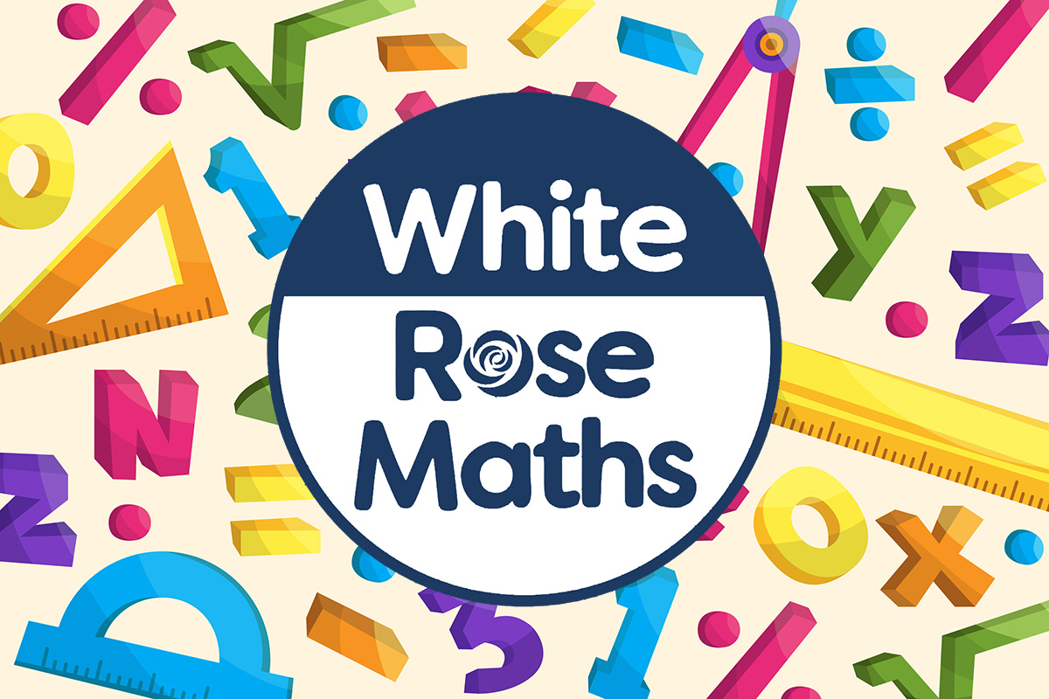
Religious Education  David and the Psalms.  By the end of this unit, pupils are expected to be able to:  - retell stories about David  - recognise their own values and the values of others  - connect Christian values and beliefs to events and teaching in the Bible.  - show that they understand how the imagery of the Psalms reveals Christian beliefs about the nature of God. |  |  | Physical Education  We will be taking part
Computing  Learners will apply their knowledge and understanding of networks, to appreciate the internet as a network of networks which need to be kept secure. They will learn that the World Wide Web is part of the internet, and will be given opportunities to explore the World Wide Web for themselves in order to learn about who owns content and what they can access, add, and create. Finally, they will evaluate online content to decide how honest, accurate, or reliable it is, and understand the consequences of false information | Science  How can living things be grouped and classified?  We will begin the half term by exploring and using classification keys to help group, identify and name a variety of living things.  We will then move on to look at states of matter. The children will take part in a variety of practical activities, while exploring how materials change state.  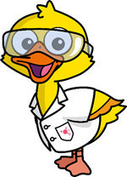
French  We will practise conversational phrases to allow us to engage in short dialogue with each other. We will respond to instructions given in French as well as using masculine and feminine nouns. | PSHE  “Being me” puzzle from our Jigsaw programme. | COAL  On Tuesday afternoons the children have a fantastic opportunity for creative, outdoor and adventurous learning.

Reminders

Our COAL afternoon is Tuesday. Don’t forget your musical instruments or Forest School clothes! Our PE days are Tuesday and Friday. On these days, please send your children in their P.E kits, which they will stay in for the entire day. Maths and English homework will be set on Fridays, to be completed by the following Friday. Reading books should be in school every day please. I am looking forward to a fantastic half term, thank you in advance for all your support.

Miss Flynn

