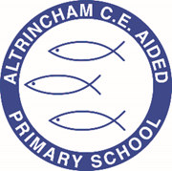

Year 5/6 Kingfishers

@ACEKingfishers

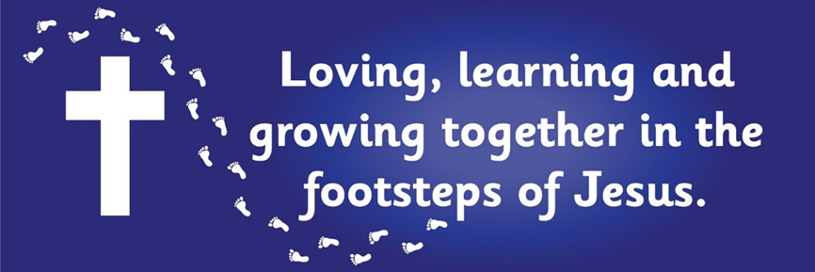

Curriculum Newsletter: Autumn 2022

Dear Parents and Carers,

I am delighted to welcome Kingfisher class to the new school year. Following our long, hot summer, we are all raring to go with our exciting units of learning. I look forward to meeting parents and carers in person, in the classroom, to share our vision and objectives for the year ahead when we hold our “Meet the teacher” evening later this month.
Details of our irresistible curriculum for this half-term can be found below.
Remember you can follow our Twitter feed and see what we are doing!

History  What was the industrial revolution and how do we see its legacy around Manchester?   | English  Key Texts:  This is the Place (poem)  by Tony Walsh  Mill Girl by Sue Reid  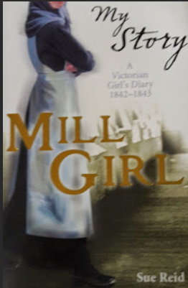 | Maths  Learning challenges from White Rose include Place Value, Roman Numerals and Four Operations  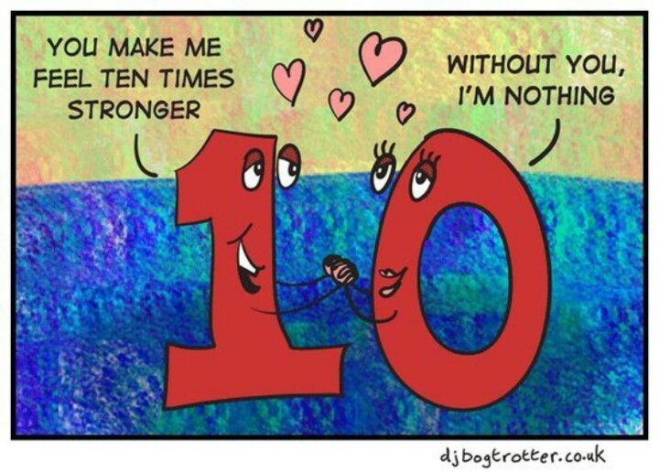
Geography  Mapwork and links to human geography milestones to provide context for deeper understanding of the Industrial Revolution.  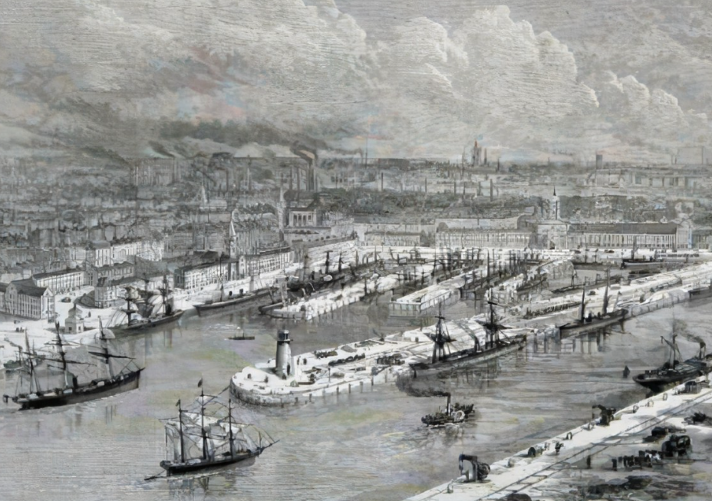 | Religious Education  We will explore Christian beliefs about creation and how these beliefs impact behaviour and values.   | Physical Education  PE lessons will take place on a Wednesday, with coaching provided by Sale Sharks.  Additionally, children will develop a range of team sport skills during COAL afternoons.  
Computing  This term we will learn how systems are linked to share information and produce outputs.  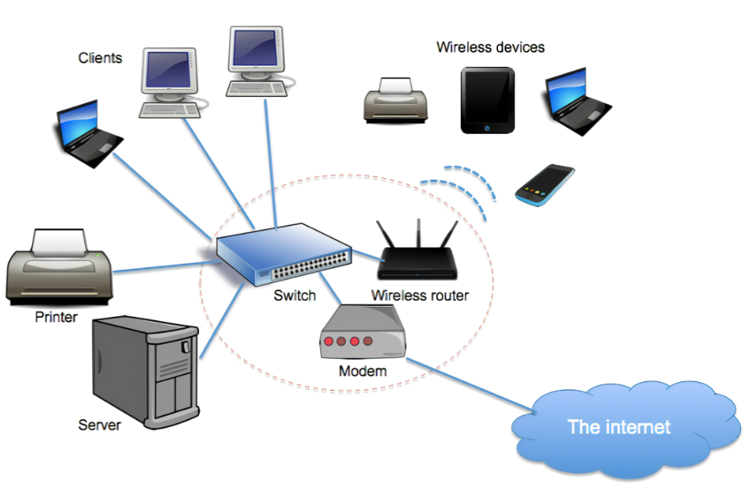 | Science  This term we explore the question, “How do scientists, engineers and designers use materials?”  We will experiment to discover the properties of different materials and learn to describe and explain their behaviour using scientific vocabulary and concepts.  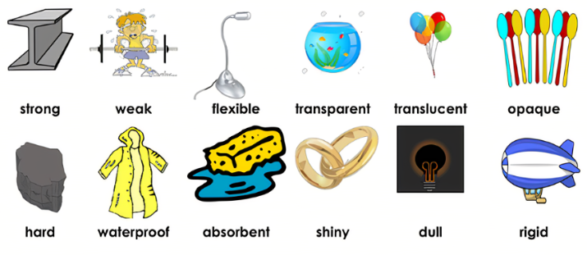
French  We will refresh our memories of French vocabulary, use of verbs and revise simple conversation and greetings.   | PSHE  “Being Me in My World” puzzle from our Jigsaw programme   | COAL  On Thursday afternoons our curriculum is fuelled by creative, outdoor and adventurous learning. This term Kingfishers will do PE, and music. Our music lessons are taught by a specialist teacher from Trafford Music Service, who will teach us to play the saxophone!  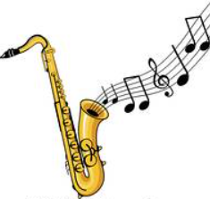

Reminders

PE will be on Wednesdays and Thursdays. Please make sure children have appropriate footwear for PE and come to school dressed in their PE kits.
Homework for maths will be set on Fridays, to be brought back to school the following Friday, when it will be reviewed in class. English homework will be set in Book Club each Monday, to be completed by the following Book Club lesson on the next Monday. Reading books and filled water bottles should be brought to school every day please. Thank you.



