New Phonics and Spelling Rules  Words contain a mixture of vowels (voyelles) and consonants (consonnes)  The letter y is called igrec  Some French words have double consonants: mm in une gomme  This accent: É é (café / pré) is called an acute accent. This accent: È è (règle) is called a grave accent. |  |  | 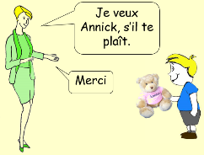  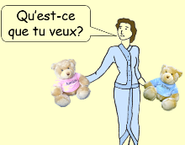  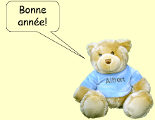  New Conversational Phrases
    ou : rouge |   au / o :  jaune / au revoir / rose |   e / eu :  le / rouge / bleu / neuf | 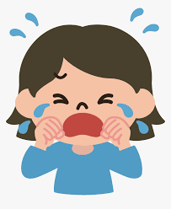  oi :  noir / trois
New Grammar Points and Sentence Structures
Nouns in French have a gender: masculine nouns and feminine nouns. We use ‘un’ to introduce masculine nouns and ‘une’ to introduce feminine nouns.

We can use a comma and a conjunction to list 3 or more nouns in a sentence eg
Voici un feutre, un pinceau et un crayon.
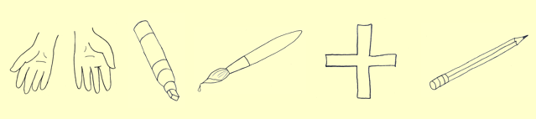
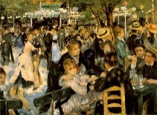
Cultural Knowledge
Paris has an underground train network called le Métro.
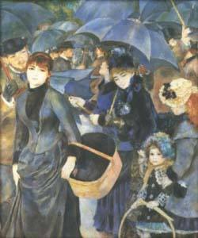
These famous paintings are by the French artist Pierre-Auguste Renoir.
Claude Debussy is a famous French composer of music for orchestras and piano.

New Vocabulary and Phrases

Numéros 7 – 10: We can have a short dialogue using these phrases:
7 | 8 | 9 | 10
sept | huit | neuf | dix
Qu’est-ce que c’est? | What is it?
Je veux…s’il te plaÎt. | I would like……please.
Voilà! | There you are!
Merci. | Thank you.

We can respond to these classroom instructions:
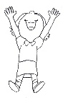 | 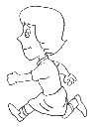 | 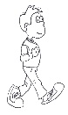 | 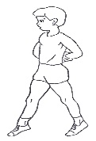 | 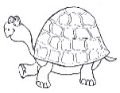 | 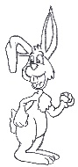
sautez | courez | marchez | marchez sur la pointe des pieds | lentement | vite

We can name some classroom items:
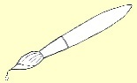 | 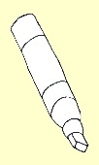 | 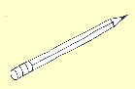 | 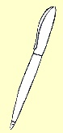 | 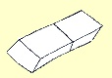 | 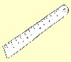
un pinceau | un feutre | un crayon | un stylo | une gomme | une règle

DBooks | Songs  J’aime la galette  Au clair de la lune  Meunier tu dors  Le fermier dans son pré  La poule grise | 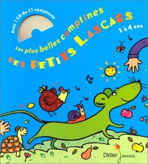  Finger Rhymes  Les Saisons  Une poule sur un mur  La Tour Eiffel
  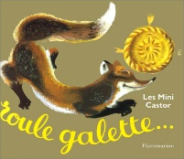 | 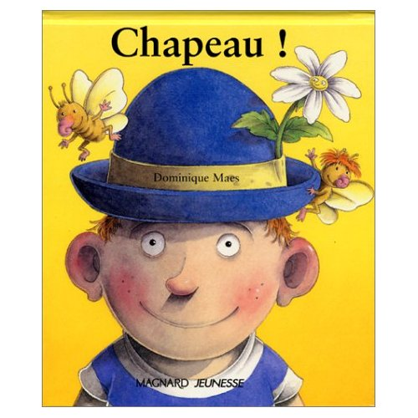 | 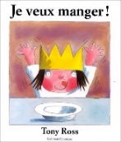 | 

