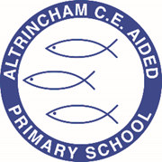

Year 3 Doves

@ACEDoves

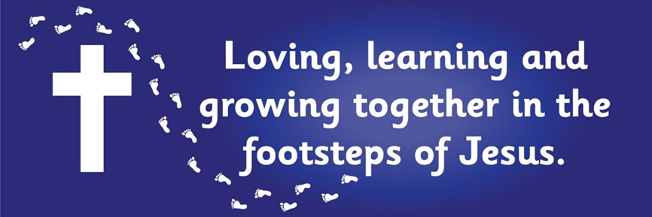

Curriculum Newsletter: Spring 1 2022

Dear Parents and Carers,

Welcome back! We hope you had a lovely Christmas break and had lots of fun! We are looking forward to a jam packed half term with very exciting learning. Details of our irresistible curriculum for this half-term can be found below.
Remember you can follow our Twitter feed and see what we are doing!

Geography    Our geography question this half term is ‘What makes the earth angry?’ We will be exploring the causes of earthquakes and volcanoes as well as their effects. The children will be revisiting their map and atlas skills while locating active, dormant and extinct volcanoes. | English  Key Text: Winter’s Child – Angela Mcallister  Our first topic will be narrative writing – we will be diving into a new key text ‘Winters Child’ and building on our mastery skills and story writing abilities. The outcome of this topic will be to write a fantasy story, based on a fable, in the style of the author Angela Mcallister.  The story follows a young boy who makes a friend to enjoy the winter snow with but soon realises that their friendship is impacting the seasons. The book explores selflessness, hope and the concept of letting go.  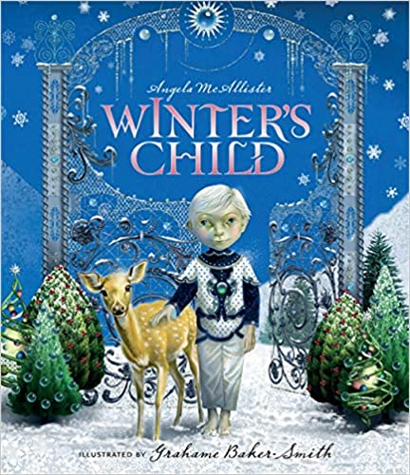 | Maths  White Rose maths unit this half term focuses on multiplication and division leading into length and perimeter.  We will also be continuing with our times tables practice.  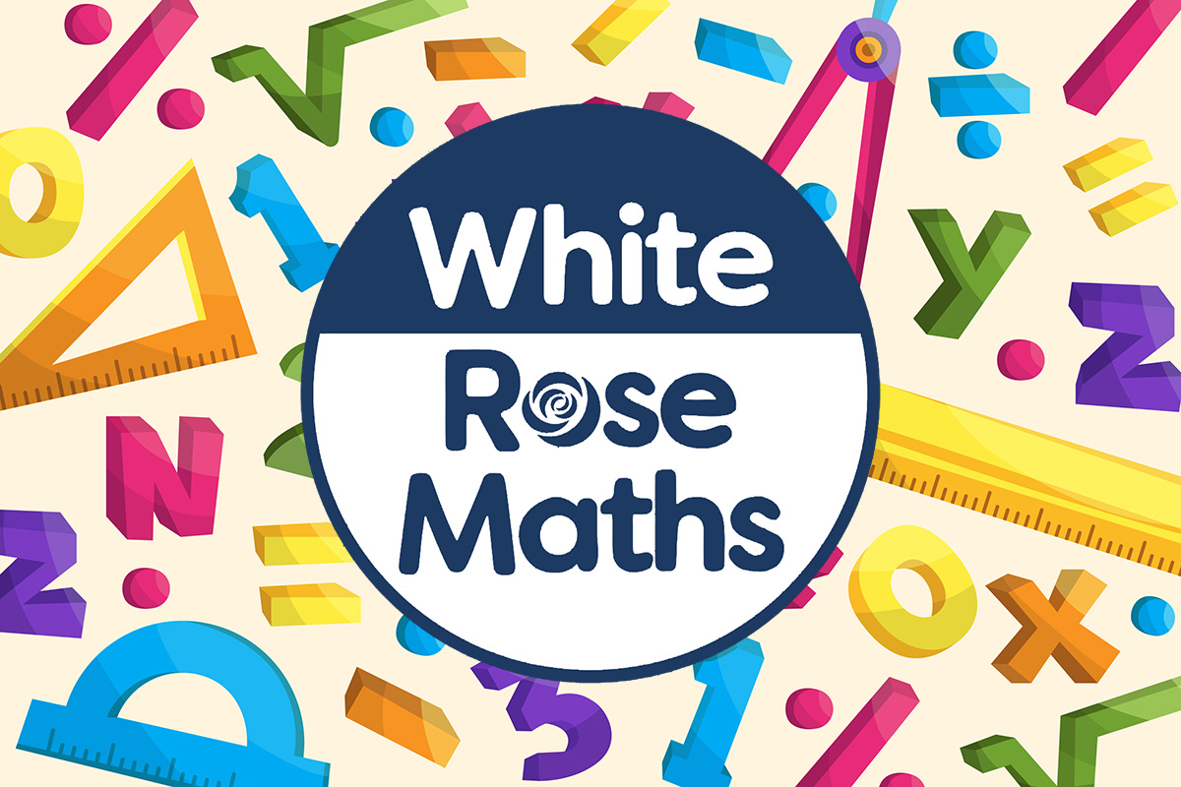
Religious Education  The key questions are as follows:  How are Christian communities different? How does belonging to a church community effect what a believer does? Why is the escape from Egypt important to Jewish people? |  | Physical Education    We will be learning and practising the key skills involved in basketball.
Computing  Our new computing unit; sequencing sounds explores the concept of sequencing in programming through Scratch. The children will be introduced to a selection of motion, sound and event blocks which they will use to create their own programs.   | Science  We will be learning about plants in our biology topic this half term. This includes labelling the different parts of each plant with their function. We will be looking at the role that flowers play in reproduction and the crucial things that plants need to survive.  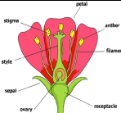
French  We will practise conversational phrases to allow us to engage in short dialogue with each other. We will respond to instructions given in French as well as using masculine and feminine nouns. | PSHE  “Dreams and goals” puzzle from our Jigsaw programme  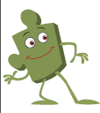 | COAL  On Tuesday afternoons the children have a fantastic opportunity for creative, outdoor and adventurous learning. This includes music taught by a specialist teacher from Trafford Music Service and PE.

Reminders

Our COAL afternoon is Tuesday. Doves have Music and PE in their COAL lessons this half term. On P.E. days please send your children in their P.E kits, which they will stay in for the entire day on Tuesday and Friday. Please be mindful that as the weather gets colder the children will need to wear tracksuit bottoms and tops; these need to be blue.
Homework for maths and English will be set on Fridays, to be completed by the following Friday. This will be set on Seesaw.
Reading books should be in school every day please.

I am looking forward to a fantastic half term, thank you in advance for all your support in these matters.

Miss Flynn

