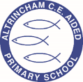
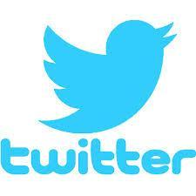
Year 3 Swallows

@ACESwallows

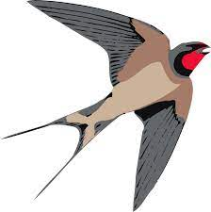
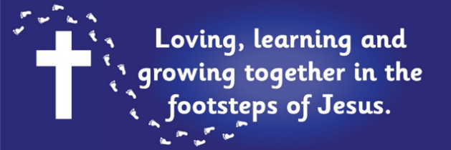
Curriculum Newsletter: Autumn 1 - 2022

Dear Parents and Carers,
Welcome back! We hope you had a lovely summer holiday and had lots of fun! We are looking forward to a jam packed half term of very exciting learning. In this table is a detailed explanation of all the learning which will take place in Autumn 1.

English  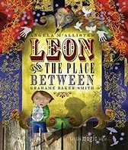  Key Text: Leon and the Place Between – Angela Mcallister  Our first topic will be narrative writing – we will be diving into a new key text ‘Leon and the Place Between’, exploring our story writing abilities. We will be writing character and setting descriptions and writing our stories in the style of the author Angela Mcallister.  ‘Leon and the Place Between’ is a beautifully illustrated book about Leon and his brothers and sister who go to a magic show, but this is no ordinary show and Abdul Kazam is no ordinary magician. |  | Maths  White Rose maths units this half term focuses on place value leading into addition and subtraction.  As well as this topic we will also be continuing with our times tables practice.  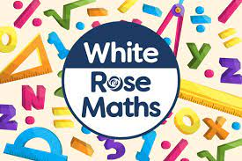
Geography  Our geography question this half term is ‘How do map makers describe where places are?’ we will be labelling locations, understanding the eight points of a compass and finding four figure grid references. Children will practice atlas and map skills as well of learning how to correctly use navigational language. | Religious Education  Our R.E. questions are – How do Christians look after the wider world and why? Why do you think the creation stories are similar and different?  We will examine why Christians try to look after the world sand. Explain how Fair Trade or World Vision might help. |  | Physical Education  Team games and ball skills.  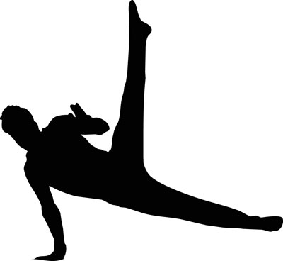
Computing  We will be looking at computing systems and networks – specifically connecting computers. We will also be exploring how digital devices work and help us and our school network. | Science  We will be learning about states of matter. Children will be comparing and grouping materials together, according to whether they are solids, liquids or gases. They will also observe how some materials change states when they are either heated or cooled and identify the part played by evaporation and condensation in the water cycle.
French  We have a weekly lesson, combining conversational French with some written work on grammar and vocabulary.   | PSHE  This half term, our Jigsaw puzzle is “All about me”  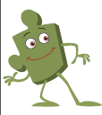 | COAL  On Tuesday afternoons the children have a fantastic opportunity for creative, outdoor and adventurous learning. This includes music taught by a specialist teacher from Trafford Music Service and PE.

Reminders
Our COAL afternoon is Tuesday. Swallows have Music and PE in their COAL lessons this half term. On P.E. days please can you send your children in their P.E kits, which they will stay in for the entire day on Tuesday and Wednesday. Please be mindful that as the weather gets colder the children will need to wear tracksuit bottoms and tops; these need to be blue.
Homework for maths and English will be set on Fridays, to be completed by the following Friday. This will be set on Seesaw.
Reading books should be in school every day please.

Meet the Teacher
On Monday 19th September, you are invited to come and meet myself, find out more about the classroom routines and have the opportunity to look around your child’s learning environment.

I am looking forward to a fantastic half term, thank you in advance for all your support in these matters.

Miss Manock

