
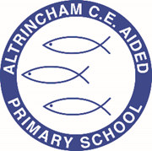
Year 2 Owl Class

@owlsACE



Curriculum Newsletter
Spring 2 - 2023

Dear parents and carers,

Welcome back everyone. I hope you had a lovely half term.

Details of our irresistible curriculum for this half-term can be found below. Remember you can follow our Twitter feed and see what we are doing!

A few reminders:

*Children will continue to wear PE kits on a Wednesday (for COAL, there is no Forest School this term) and Friday for the remainder of the spring term. Please remove any jewellery or provide tape to cover earrings that can not be removed.

*School is a nut free school, this includes no nuts in lunch boxes (no hazelnut spreads) and sweets/chocolates brought in to share for birthdays.

*The school day is 8.50am to 3.20pm. The gates are locked at 9am and any late comers will need to report to reception. If any children have not been collected by 3.30pm they will be taken to the Arc after school club and charges may apply.

Dates for the diary:

World Book Day: Thursday 2nd March – children are invited to dress up as a book character or come in their PJs for a cosy up with a book.

Reading Breakfast: Thursday 2nd March

Parent/Carer – Teacher meetings: Tuesday 21st & Thursday 23rd March

Y2 SATS information presentation: Thursday 30th March 3.30pm

Friday 31st March: break up for Easter break 2pm.

Monday 17th April: Summer Term starts

Any queries you can always catch me at morning drop off, afternoon pick up and via seesaw.

Best wishes,

Miss Stevens

English  The English Framework at ACE includes a daily session of Book Club. In addition to Book Club there will also be English lessons. These will include grammar and spellings bursts and activities around a key text. This half term we are continuing our new scheme ‘Pathways to write’. The text for Y2 this half term is ‘Major Glad, Major Dizzy’ by Jan Oke. Y1 text is ‘The Curious Case of the Missing Mammoth’ by Ellie Hattie and Karl James Mountford.  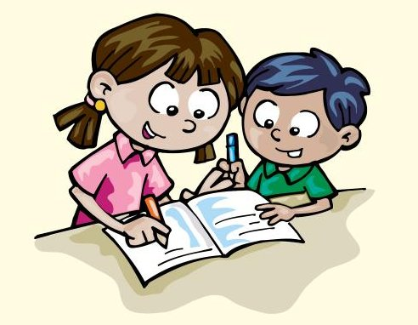 |  | Maths  Year 1  We follow the White Rose Maths Scheme. We will be looking at place value within 50. Then we move onto length and height; then mass and volume.  Year 2  We follow the White Rose Maths Scheme. We will be completing the unit multiplication and division before moving to length and height; then mass, capacity and temperature.  
Religious Education  In our RE lessons we will be exploring the resurrection and answering the key questions: what happens in church at Easter? Why was the empty tomb good news for Christians? Why is the resurrection story important to Christians?  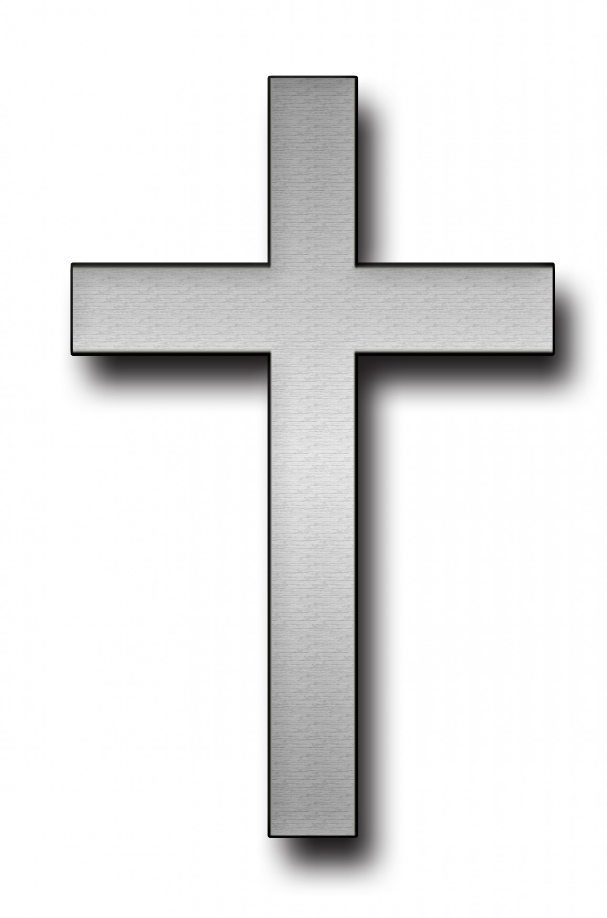 | Science  We will be looking at different animals and the habitats they survive in.  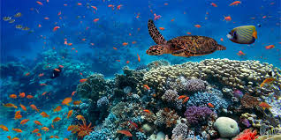 |  | Computing  We will be following the Teach Computing units of  Y1 –Data and information – grouping data  Y2 – Data and information - pictograms.  
Geography  We will be identifying where the continent of Oceania is, then we will be focusing on Australia and asking, what is it like ‘Down Under’?   | COAL  Creative, outdoor and adventurous learning. These sessions will be on a Wednesday afternoon and include Forest School, music and sports.  Y1 – will have Forest School  Y2 – will have PE and music.  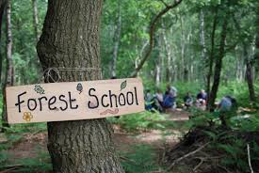 |  | PE  This half term the children will have PE lessons on a Friday. PE sessions will be delivered by our coach Sam Sheridan.  
PSHE  We follow the Jigsaw scheme for PSHE. The theme for this half term is ‘Healthy Me.’  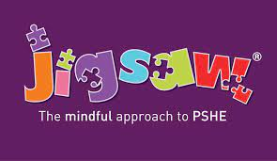 | Worship  Every week your child will be participating in whole school, Key Stage and class worships. The Christian value we will be discussing this half term is ‘Forgiveness.’  

