Advice and Guidance sheets from Trafford Educational Psychology Service during COVID-19

April 2020

Introduction
COVID-19 has brought unprecedented changes and demands to Trafford schools, families, children and young people.
Drawing on our understandings of child development, learning and emotional well-being, the Educational Psychology Service are here to offer support to all Trafford schools, families and children/young people to cope with the challenges arising from COVID-19.
Teaching staff, parents/carers can access this support by emailing the service TraffordEPS@trafford.gov.uk or by organising contact through their SENCO.
In order to help schools, parents/carers, children and young people navigate the wealth of advice and support available at this time the Educational Psychologists have compiled a list of relevant COVID-19 resources which can be accessed online organised into ‘guidance sheets’.
Contents
- Guidance and resources for the under 5s Page 3
- Guidance and resources for Primary aged children Page 5
- Guidance and resources for Secondary aged pupils Page 8
- Guidance and resources for pupils with SEN Page 11
- Adult support and self-care for parents/carers and teachers Page 13
- Appendices Page 15
Please do not hesitate to get in touch with the team if you would like further advice and guidance.

Guidance and resources for the under 5s
- General advice
During periods of uncertainty, children under 5 will need plenty of affection and opportunities for play and social cues that they are safe. They will need to establish reassuring routines in their day and, for those with the communication skills to understand, simple but clear explanations about what is happening and why with a key focus on keeping everyone well. Below are some links that may help to support these goals:
- A comprehensive guide to supporting young children through COVID-19 created by North Port Talbot Inclusion Service covering a range of topics relevant to the under 5s. This includes tips for: supporting younger children, advice relating to explaining COVID-19, exploring emotions, calming activities, home based learning and support specific to the needs of little children with language and social communication needs: http://www.npted.org/schools/primary/ynysfach/Home%20Learning/NPT%20Early%20Years%20COVID%20booklet%20Final.pdf

- Explaining COVID-19 restrictions:
In addition to simple explanations, stories can help children understand and feel comforted during a disruption to their normal routines:
- General advice relating to age range of child from the British Psychological Society: https://www.bps.org.uk/sites/www.bps.org.uk/files/Policy/Policy%20-%20Files/Talking%20to%20children%20about%20illness.pdf
- A child friendly story about COVID-19 restrictions (suitable for children with developed language): https://subscriptions.earlyyearsstorybox.com/wp-content/uploads/2020/03/Dont-Worry-Little-Bear-Book.pdf
- A story book that comforts children when are separated from family and friends (suitable for children with developed language): The Invisible String by Patrice Karst

- Supporting emotional well-being:
There are a number of ways to support children to maintain their emotional wellbeing during COVID-19. This may include supporting the child to develop their emotional literacy and to express themselves through play.
- Simple activities to help your child to relax: https://www.bbc.co.uk/cbeebies/joinin/seven-techniques-for-helping-kids-keep-calm
- Advice around supporting children’s emotional needs through play during periods of crisis: http://ipaworld.org/resources/for-parents-and-carers-play-in-crisis/
- Simple techniques to support children to understand their emotions as they experience them, based on Emotion Coaching, at this age there should be a key focus on labelling the emotions and linking it to their experience: https://cdn.gottman.com/wp-content/uploads/2017/06/Five-steps-to-emotion-coaching-FB-graphic-.png
It is important to remember that effectively supporting a child’s wellbeing will require first supporting your own (see sections applicable to adult support for advice around this). Where there is a high level of concern about a child’s well-being it will be important to seek support through discussion with the SENCO or other family support services.
- Advice relating to loss and bereavement:
Sadly some children will experience the loss of a loved one due to Coronavirus. How you can support a child to process this will relate to their developmental stage, but the most important to offer them is comfort and reassurance. Sometimes activities can be used to support children to cope with what has happened. Here is some information to support children through this process:
- This is a short video from the charity Child Bereavement UK explaining grief in relation to a child’s developmental stage, including simple guidance on how to support the under 5s through explanation, affection, reassurance and routine: https://www.childbereavementuk.org/childrens-understanding-of-death-at-different-ages
- This booklet is designed by the childhood bereavement charity Winston’s Wish for parents, carers, childcare professionals and other adults supporting children up to the age of 5 who have experienced the death of a parent or carer: https://shop.winstonswish.org/collections/books/products/never-too-young-to-grieve
Where there are concerns, further advice and guidance can also be sought from Winston’s Wish: https://www.winstonswish.org/helpline/
- Play based learning ideas:
For children at home, parents may want tips and advice to support children’s learning and development through play. Here are some ideas:
- Government advice for pre-schoolers: https://www.gov.uk/guidance/help-children-aged-2-to-4-to-learn-at-home-during-coronavirus-covid-19
- Activities for children aged between 0-3: https://www.zerotothree.org/resources/series/play-with-me
Guidance and resources for Primary aged children
During times of uncertainty children will need to feel loved and to regain a sense of ‘normality’ which can be acquired through routines and time to relax and play. Children of this age will have some understanding of what is happening and, like adults, may experience worries and frustrations. How children display these worries and frustrations may be reflected in a variety of ways e.g. a change in their resiliency levels, behaviours, appetite, sleep patterns and sometimes their development (children can appear to ‘regress’ when they are anxious). By building a sense of emotional security through positive interactions and reassurance, lots of children will be able to adapt. If however any additional support and guidance is needed please speak to the school SENCO.
Here are some ideas to support children at this time:
- Talking to children about COVID-19 and illness:
Children will be aware that something is wrong and may be confused about what COVID-19 means. It is important to share information in an accessible way that helps children to understand and help make them aware that there are risks but that they are likely to be safe, and that they can have a positive impact by following what the restriction guidelines e.g. social distancing, handwashing etc, and by doing nice things for others etc. Whilst it is important to be honest, it is also important to not over expose them to adult media and conversations that are likely to make them feel anxious. Here is some advice and activities that can support you in communicating this message:
  - General advice relating to age range of child from the British Psychological Society: https://www.bps.org.uk/sites/www.bps.org.uk/files/Policy/Policy%20-%20Files/Talking%20to%20children%20about%20illness.pdf
  - Simple tips to help answer children’s questions relating to COVID-19 restrictions (see appendix 1)
  - Stories and activities used to support an understanding of Coronavirus:
- Story and activities that support in explaining Coronavirus (suitable for Key Stage 1 children): https://660919d3-b85b-43c3-a3ad3de6a9d37099.filesusr.com/ugd/64c685_0a595408de2e4bfcbf1539dcf6ba4b89.pdf
- Free children’s book illustrated by Axel Scheffler (illustrator of the Gruffalo) (suitable for Key Stage 2): https://issuu.com/nosycrow/docs/coronavirus_ins/1?ff&hideShareButton=true

- Supporting children’s emotional needs
Many children will seem unperturbed by the changes, but it is natural that children will feel a level of uncertainty about what is happening. For those who need it, there are some child friendly resources to help with exploring and managing the anxieties that could accompany COVID-19 a positive way:
- A government publication including a simple story with activities to help children understand and manage anxiety associated with COVID-19 (Key Stage 1): https://www.childrenscommissioner.gov.uk/wp-content/uploads/2020/03/cco-childrens-guide-to-coronavirus.pdf
- Activity sheets to help children manage COVID-19 in a positive way (Key Stage 2): https://www.kiddycharts.com/assets/2020/04/Covid-19time-capsule.pdf
- Calming techniques to support children from the BBC:
  - Activities to support children to feel calm (adapt according to age, focussing on the same core principles: https://www.bbc.co.uk/cbeebies/joinin/seven-techniques-for-helping-kids-keep-calm?collection=parenthood-tips-and-tricks
- Trafford’s Just Psychology are offering online parent workshops on ‘Behaviour Difficulties’, ‘Anxiety’ and Online Safety and Social Media, for further details please visit: https://www.facebook.com/JustPsychology

It is important to remember that effectively supporting a child’s wellbeing will require first supporting your own (see sections applicable to adult support for advice around this).

For children displaying high levels distress, it will be important to speak to your SENCO or GP.
- Supporting Year 6 transition to secondary school
For many Year 6 children the ‘normal’ transition from primary to secondary school has been significantly disrupted and as such it is important to give children the opportunity to have shared experiences with their class mates through alternative means, and it may be helpful to work through some activities to mentally prepare the child for the transition. Here are some examples.
- Activities from the BBC to support transition from Primary to Secondary school: https://www.bbc.co.uk/teach/transitioning-to-secondary-school/zkc9pg8
If you are very worried about your child’s transition, please speak to the school SENCO.
- Advice relating to loss and bereavement:
Sadly some children will experience the loss of a loved one due to Coronavirus. As with little children, how you can support a child with this will relate to their developmental stage. The most important thing you can offer a child is emotional security, comfort and reassurance. Sometimes activities can be used to support children to cope with what has happened. Grieving is a difficult but natural process and takes time. Here is some information to help make sense of this and support children through this process:
- This is a short video from the charity Child Bereavement UK explaining grief in relation to a child’s developmental stage, including simple guidance on how to support children between the ages of 5 and 11: https://www.childbereavementuk.org/childrens-understanding-of-death-at-different-ages
- Winston’s Wish a charity set up to support children experiencing bereavement have created Coronavirus specific resources: https://www.winstonswish.org/coronavirus/
- A story book that may comfort children when are separated from family and friends (suitable for children with developed language): The Invisible String by Patrice Karst
- Further advice and guidance can also be sought from Winston’s Wish: https://www.winstonswish.org/helpline/
If a child is particularly struggling, they may benefit from further professional support and this can be discussed with school.
- Educational resources
For children who are at home, some parents/carers may wish to supplement learning opportunities with additional activity or online learning materials. The extent to which this can happen will be dependent on personal circumstances and parents/carers should not feel pressured to be ‘teachers’.
- Government publication signposting parents to learning programmes (see sections suitable for Primary aged children): https://www.gov.uk/government/publications/coronavirus-covid-19-online-education-resources/coronavirus-covid-19-list-of-online-education-resources-for-home-education and https://www.gov.uk/guidance/supporting-your-childrens-education-during-coronavirus-covid-19 and https://www.thenational.academy/information-for-parents-pupils
- BBC daily learning programme (Year 1-10): https://www.bbc.co.uk/bitesize/dailylessons
- List of educational activities and resources for children: https://www.childrenscommissioner.gov.uk/coronavirus/resources/
- Maintaining safety in virtual classrooms and online:
  - https://www.childrenscommissioner.gov.uk/coronavirus/keeping-classrooms-safe-online/
  - https://www.thinkuknow.co.uk/parents/Support-tools/home-activity-worksheets/
Guidance and resources for Secondary aged pupils
Young people will experience a different set of challenges in relation to COVID-19. Maintaining a sense of independence and feeling connected to their peer groups is very important to many young people and the restrictions that have come with COVID-19 will hamper this need. Many young people will be able to access adult media narratives but they may not have fully developed emotional coping skills to manage the impact of these narratives. Just like younger children, young people will need to feel a sense of routine, emotional security, and may need support to understand and adapt to restrictions and manage the fears and worries associated with this.
- Talking to young people about COVID 19 and illness
Although many young people are able to understand what is happening and why, a supportive dialogue may help a young person make senses of information, adjust their behaviours in line with the restrictions, and serve to ‘bust’ some of the myths that may be circulating in their mind.
- General tips for parents and teachers around talking to different age groups from the British Psychological Society: https://www.bps.org.uk/sites/www.bps.org.uk/files/Policy/Policy%20-%20Files/Talking%20to%20children%20about%20illness.pdf
- Accessible BBC news sources (please note that it will be best to get the most up to date version of events): https://www.bbc.co.uk/newsround/51204456
- Simple tips to help young people follow COVID-19 restrictions (see appendix 1)

- Supporting their emotional needs
Young people are approaching or are likely to be going through rapid changes in their development which can impact on their emotional coping skills and expression of emotions. Early research is suggesting this age group may need more emotional support to cope with the changes that have arisen as a result of COVID-19 than young children. Vulnerable groups such as young people who have displayed anxieties and low mood in the past may particularly need support to manage the challenges. Talking to young people and providing reassurance, helping them to develop positive routines and habits are all likely to support them with this e.g. exercise, calming activities, finding alternative ways to maintain social contact with friends etc. For young people displaying significant emotional needs affecting their day-to-day functioning or that are leading to risky behaviours, it is appropriate to seek professional help through your GP or the SENCO.
- General advice for young people and parents on the mental health impact of COVID-19 from the mental health charity Young Minds: https://youngminds.org.uk/about-us/media-centre/press-releases/youngminds-publishes-advice-for-young-people-and-parents-on-mental-health-impact-of-coronavirus/
- Tips for developing emotionally healthy habits: https://youngminds.org.uk/blog/young-peoples-self-care-tips-for-self-isolation/
- Soothing self-help tools for teenagers:
  - https://youngminds.org.uk/blog/young-peoples-self-care-tips-for-self-isolation/
- Online support:
  - Kooth online counselling and wellbeing platform for children and young people: https://hub.gmhsc.org.uk/mental-health/kooth/ (please see appendix 3 for an easy user guide for these services)
For vulnerable young people engaging in risk taking behaviours, additional advice can be sought from Talkshop Trafford via: talkshop@trafford.gov.uk
It is important to remember that effectively supporting a child’s wellbeing will require first supporting your own (see sections applicable to adult support for advice around this).
For children displaying high levels distress, it will be important to speak to your SENCO or GP.
- Advice relating to loss and bereavement:
Sadly some young people will experience the loss of a loved one due to Coronavirus. The most important thing you can offer a young person people is emotional reassurance and the availability of your support. Grieving is a difficult but natural process. There is no right or wrong way to experience this and most people will just need time and the support of the people they trust. Here is some information to support children through this process:
- This is a short video from the charity Child Bereavement UK explaining grief in relation to a child’s developmental stage, including simple guidance on how to support young people: https://www.childbereavementuk.org/childrens-understanding-of-death-at-different-ages
- Winston’s Wish a charity set up to support children and young people experiencing bereavement have created Coronavirus specific resources: https://www.winstonswish.org/coronavirus/
- Self-help tips for young people experiencing bereavement from the NHS: https://www.nhs.uk/conditions/stress-anxiety-depression/bereavement-and-young-people/
If a young person is particularly struggling, they may benefit from further professional support and this can be discussed with school.
- Educational resources
For young people who are at home, some parents/carers may wish to supplement learning opportunities with the additional resources. The extent to which this can happen will be dependent on personal circumstances and parents/carers should not feel pressured to be ‘teachers’ especially considering that Secondary education requires mores specialist knowledge of subject areas. Where young people want to take charge of their own learning development it will be important to help them find ways to access learning activity.
- Government publication signposting parents to learning programmes (see sections suitable for Secondary aged pupils): https://www.gov.uk/government/publications/coronavirus-covid-19-online-education-resources/coronavirus-covid-19-list-of-online-education-resources-for-home-education and https://www.thenational.academy/information-for-parents-pupils
- BBC daily learning programme (Year 1-10): https://www.bbc.co.uk/bitesize/dailylessons
- Maintaining safety in virtual classrooms and online:
  - https://www.childrenscommissioner.gov.uk/coronavirus/keeping-classrooms-safe-online/
  - https://www.thinkuknow.co.uk/parents/Support-tools/home-activity-worksheets/

Guidance and resources for children and young people with SEN
Children and young people with Special Educational Needs may have an additional set of needs that will require additional or different types support. For some there may be aspects of COVID-19 restrictions that both alleviate and increase anxiety. Parents/carers worried about their children are welcome to get in touch directly with the Educational Psychology Service or seek guidance via the school SENCO. Here are some ideas to support children and young people with SEN while that are at home. It is important to acknowledge that there are a lot of ideas here and parents/carers will need to think about which of the resources can be achievably used:
- Government guidance with links relevant to SEND: https://www.gov.uk/guidance/help-children-with-send-continue-their-education-during-coronavirus-covid-19
- Advice to supporting children and young people with Autism Spectrum Conditions and/or social communication needs and learning needs through routine during school closures from NHS Wales: http://www.cardiffandvaleuhb.wales.nhs.uk/sitesplus/documents/1143/Supporting%20Children%20with%20LD%20%26%20ASD%20with%20COVID%20Isolation.pdf?fbclid=IwAR05d_xxsj0xfvEqCiqjabdw4r4Ir9XMpOwurjdkXV0ZBRcyVk92HXI-cSI
- A variety of SEN related learning activities and resources collated by a Speech and Language Therapist for parents of children with needs associated with: speech and language, motor coordination, social communication, attention and concentration, sensory impairment, specific learning needs: https://chatterpack.net/blogs/blog/list-of-free-speech-language-communication-and-send-resources-for-schools-and-parent-carers?fbclid=IwAR3cGzrnvrlBIbfQGH_EslOzrb45Soj-wGNE57LEIsKX2FzZPvaAdx0AMBo
- Activities collated by Autism specialists from Stars Team, aimed at helping children with Autism to understand COVID-19, express how they feel, advice regarding Early Years, School aged Post 16 pupils (this includes resources and activities and a hospital passport which will be suitable for a variety of SEN needs): http://www.starsteam.org.uk/coronavirus-resources
- Other Autism Spectrum friendly COVID-19 resources:
  - Sensory Integration network – handwashing tips for people with sensory difficulties: https://www.sensoryintegration.org.uk/News/8821506
  - Roddensvale School – a Social Story about Coronavirus
https://www.facebook.com/487644451375099/posts/1630632433742956/
  - Carol Gray social story https://carolgraysocialstories.com/wp-content/uploads/2020/03/Pandemics-and-the-Coronavirus.pdf
- Government guidance relating to additional rights to exercise for those with SEN: https://www.gov.uk/government/publications/coronavirus-outbreak-faqs-what-you-can-and-cant-do/coronavirus-outbreak-faqs-what-you-can-and-cant-do (see FAQ 15 for new guidance)

Support and self-care applicable to parents/carers and teachers
Adults are able to support children and young people best when they are able to take care of their own needs. In addition to the anxieties that COVID-19 brings around health and managing new restrictions, COVID-19 has brought a number of additional demands to teachers, parents and carers which may understandably lead to a feeling of ‘loss of control’, low mood and anxiety. As such reaching out to supportive family members and friends, and taking small steps to engage in a positive self-care routine can make the difference between feeling able to cope and not feeling able to cope. Here is some links relating to well-being and accessing practical support to help with additional worries that come with COVID-19.
- Advice and guidance around supporting teacher resilience during COVID-19 from the British Psychological Society: https://www.bps.org.uk/sites/www.bps.org.uk/files/Member%20Networks/Divisions/DECP/Teacher%20resilience%20during%20coronavirus%20school%20closures.pdf
- Virtual classroom tools for teachers: https://www.thenational.academy/information-for-teachers
- A video explaining how to regain a sense of control during the coronavirus crisis based on sound understandings in psychology: https://m.youtube.com/watch?v=BmvNCdpHUYM
- The NHS programme ‘5 ways to improve mental health and well-being’ through planned activity: https://www.nhs.uk/conditions/stress-anxiety-depression/improve-mental-wellbeing/
(Note that when using a planned activity approach it will be important to think flexibly and creatively so that goals are achievable. This may focus on one thing at a time)
- Activities based on mindfulness techniques that can be built into everyday activity, described by the Mental Health charity, MIND: https://www.mind.org.uk/information-support/drugs-and-treatments/mindfulness/mindfulness-exercises-tips/
- Online Mental Health support services in Greater Manchester: https://www.gmmh.nhs.uk/trafford-primary-care-mental-health-and-wellbeing-service/ and https://hub.gmhsc.org.uk/mental-health/digital-mental-health-resources/
- Support for families experiencing a COVID-19 bereavement: https://www.cruse.org.uk/get-help/coronavirus/coronavirus-useful-links
- Practical support:
- Scroll down for advice relating accessing financial, employment and housing support: https://www.mind.org.uk/information-support/coronavirus/coronavirus-and-your-wellbeing/#collapsee4239
- For help with shopping, telephone support and food parcels, residents can call the Trafford Community Response Line number on 0300 3309073
- Information on other services available during COVID-19 including access to local GP support, Credit Union, Trafford Domestic Abuse Services (see appendix 3)
- In addition to this the Family Information Service is available to support with questions and signposting to appropriate services in Trafford: https://www.trafford.gov.uk/residents/contacts/secure/family-information-service.aspx

Appendix 1
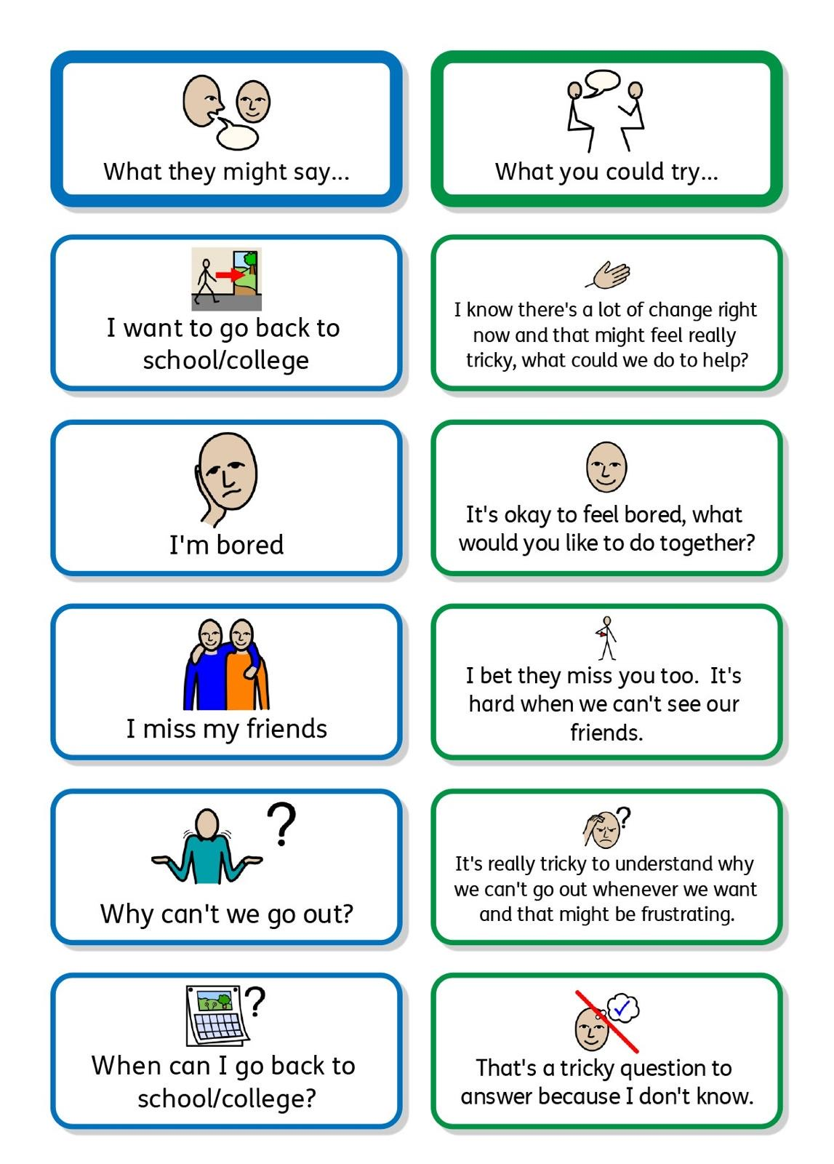

Appendix 2

Appendix 3


